|  |
| --- |
| Colt Number Hosting  25th March 2023 Release Notes |

# Introduction

This document describes the Colt Number Hosting 25th March 2023 release.

The release will focus on:

* Number on Demand & API improvements
* Introduction of New Address Validation and getLAC REST API
* NL regulatory changes
* Port-Out lifecycle changes

**These changes might imply development at your end, so please read this document carefully.**

The changes in this release require your support during our test period. The Customer UAT is planned from 27th Feb 2023 to 14th March 2023. Please get in touch with [NumberHostingUATSupportTeam@COLT.NET](mailto:NumberHostingUATSupportTeam@COLT.NET) if you would like to participate in the UAT.

# Document change control

|  |  |
| --- | --- |
| **Version** | **Change description** |
| V1 | 25th March 2023 Release note |
| V2 | Updated release notes with   * Updated Customer UAT dates * Added table to highlight mandatory parameters required for ‘GET/LACbyLocation API * Updated NL port-out order lifecycle * Updated address management OAS specification added in Appendix B |
| V3 | Updated release notes (changes highlighted in blue)   * Updated enhancement 1 and added new change(row 15) in **Numbers on Demand (NOD) and B2B API improvements** section * Clarification provided in NL Enhancements section for CLI level updates |

# Numbers on Demand (NOD) and B2B API improvements

Below are 14 improvements targeted for release on 25th March 2023. Updated XSDs and API OAS specifications can be found in the **Appendix A**: XSD and **Appendix B**: API specifications.

| Sr no | Functionality | Interface | Improvement Description | Country Scope |
| --- | --- | --- | --- | --- |
| 1 | All APIs | B2B API (SOAP/HTTPS) | All SOAP APIs will now only support CLI start and CLI end fields in E164 format (+<countrycode><CLI>).  The split format of input should not be provided. Please refresh the WSDL at your end for the same.  ***Please note:*** *this is a code breaking change and you’re expected to make the changes at your end to avoid any validation failure post March release go-live* | All |
| 2 | Address Update | B2B APIs | **For PREMIUM customers only**  Address Update API currently supports three ‘Action’- ADD, MODIFY and REMOVE  As the part of this release, we will no longer support ‘REMOVE’ action. An appropriate validation error message will be thrown if this action is passed.  ***Please note:*** *this is a code breaking change and you’re expected to make the changes at your end to avoid any validation failure post March release go-live* | All except DE, AT, IT, CH and Zone B countries |
| 3 | Number Deactivation | NOD and B2B API (SOAP/HTTPS) | **For PREMIUM customers only**  From this release onwards PREMIUM customers will be able to perform partial deactivation on Colt numbers in “activated” status) via NOD and B2B API.  No change for Ported-in activated numbers | All DE, AT, IT, CH and Zone B countries |
| 4 | New port-in and 'Modify Port' transaction Data update APIs | B2B APIs | New port-in and 'Modify Port' transaction Data update APIs support the 'Current Operator' field in all countries. This field will be validated against the allowed operator values in these respective countries. This is similar to what happens today in the UK.  Only allowed values (please refer to **Appendix C: Current Operator list**) will be accepted at the time of request submission. Requests with faulty values will get rejected with a valid business failure.  Impacted APIs: SOAP New Port-in and transactionData Update (action: Modify Port) API and equivalent REST APIs  ***Please note:*** *this is a code breaking change and you’re expected to pass the exact operator value provided in Appendix C from your end to avoid any validation failure post March release go-live* | All except NL, DE and UK |
| 5 | All | NOD, B2B APIs | Introduction of **nomadic LAC (30) in Portugal**:  From our March release we will be able to offer location independent/nomadic (30) numbers in Portugal.  NOD: direct activation and reservation - a new option for location independent search will be available  B2B APIs: ‘VOIP’ category will be accepted for PT for free number search  validGeographicAddress REST API will return nomadic LAC in validLAC response  LAC validation to be skipped for requests which contain Nomadic LACs | PT |
| 6 | Address Update | NOD, B2B APIs | New optional field ‘CustomerReference’ is added in address update  Allowed length: 50  Impacted functionalities: Address update (NOD and REST API) and Bulk address Update (NOD), Order/Number report, order Details-NOD, GET/{orderID} REST API, getNumberDetail SOAP API, callBack API notifications  ***Please note:*** to use this field in APIs, a code change is required at your end. As it’s an optional field, it is not a code breaking change. | All |
| 7 | Number reservation, number activation, Port-In, Address Update, Bulk (activation and Port-In, address update) | NOD, B2B APIs | Currently the special characters below are supported along with alphanumeric characters:  A-Z  a-z  0-9  Underscore (_)  Hyphen (-)  Plus (+)  Full stop (.)  Ampersand (&)  Quote (“)  Greater than (>)  Less than (<)  Additional 3 characters will be supported in ‘customer reference field’ post this release :  Commas (,)  Colons (:)  semicolons (;) | All |
| 8 | My Telephone Number page, numberEnquiry SOAP API and numberCollection REST API | NOD, B2B APIs | Today resellers are not able to search for CLIs within a range via NOD and B2B APIs for Germany. Only exact range details are accepted in a search.  With this release, it will be possible to search for CLIs within a range using numberEnquiry API (search by CLIDetails) and in NOD-My telephone number page. | DE |
| 9 | Number Reservation, Activation, Port-In and bulk (activation & port-in) | NOD, B2B APIs | Telephone Number Logic check  For number reservation, activation, port-in and bulk (activation & port-in) requests, the requested number range should follow 0-9 rule and 1,10,100,1000,10000 block size rule.  Non-standard block size and range start (not ending with 0) and range end (not ending with 9) will not be accepted in reservation, activation and port-in requests. A validation error will be thrown for these invalid requests upfront.  Block size rules:   * single numbers * range of 10: range start and end should end with 0-9 * range of 100: range start and end should end with 00-99 * range of 1000: range start and end should end with 000-999   For **port-in** **requests** where multiple ranges can be requested, block size needs to be followed. Note for Italy only one range per port-in request is allowed.  **Single numbers:**  Adding single numbers in the form of a range is not allowed.  For example in CH:  0445601010-0445601014  (5 single numbers) 🡪 not allowed.  Each single number has to be added individually by row as shown below separately in one single row for CH:  0445601010  0445601011  0445601012  0445601013  0445601014  **Block of 10 numbers:**  Adding multiple blocks of 10 numbers in the same range is not allowed.  For example: 0445601010-0445601049  (40 numbers) 🡪 not allowed.  Each block has to be added separately:  0445601010 to 0445601019  0445601020 to 0445601029  0445601030 to 0445601039  0445601040 to 0445601049    **Block of 100 numbers**:  Adding multiple blocks of 100 numbers in the same range is not allowed.  For example: 0445601000-0445601399 (400 numbers)  Each block has to be added separately:  0445601000-0445601099  0445601100-0445601199  0445601200-0445601299  0445601300-0445601399 | IT and CH |
| 10 | Partial Port-In | NOD, B2B APIs | If a port-in order contains a number within a range in any of these statuses:: port-out, returned or transferred, then, we will allow the Port-In reservation of that number instead of throwing an error. | All countries except DE & Zone B countries |
| 11 | Port-In | NOD, B2B APIs | New Administrative Addresses (introduced in July 2022) are validated in a similar way to the Installation (End customer) address. This Administrative Address is used by end customers who wish to provide an alternative porting address and you can now capture a PO Box (Postbus) address.  Post this release, in the Administrative Address, the ‘Street name’ field can be populated with the ‘Postbus’ value and on the basis of this, the port-in request can progress.  The name ‘Postbus’ must be clearly entered in upper or lower case characters in the field, along with other information. | NL |
| 12 | Port-In | NOD, B2B APIs | When a port-in request is rejected automatically because the number status in our inventory is not valid for the port-in request to proceed, we currently do not show the faulty numbers in the request.  getTransactionDetails SOAP API, GET/{orderID} REST API, order details (NOD) will display the CLIs and their associated details to provide further clarity for the rejection.  Details can be found in the XSD (Appendix A) and API specification (Appendix B) | All |
| 13 | orderDetails | NOD, B2B APIs | The losing carrier’s OKU code will be returned in getTransactionDetails SOAP API and GET/order{orderID} REST API response. The same will be present in the Port-In email notifications. | CZ |
| 14 | Activation, Port-In, Address Update | NOD, B2B APIs | Like the Zone A countries, we will support the Service type flag in zone B countries (Allowed values: SUBSCRIBER, SERVICE).  SOAP API field name: additionalCustRef1  REST API field name: serviceType | Zone B countries |
| 15 | Activation, Port-In and Address Update | B2B APIs (SOAP/HTTPS and REST) | Customer Type field is only applicable for countries listed below.  BE, DE, IE, IT, NL & SE {6}: Business and Residential  for other countries this field is not applicable. If passed then validation error will be thrown. | All except BE, DE, IE, IT, NL & SE |

# New Address Validation and getLAC REST API

Please refer to the OAS specification for address management in **Appendix B: API specifications.** These API will be available for 13 Colt countries only as the part of this release. it will be extended to Zone B countries in one of the later releases.

### Address Validation

This section describes the API functions to validate an address.

#### Description

POST/validateAddress API validates the address using country specific parameters.

#### Input parameter(s)

Parameters vary depending on the country. Please find a summary below:

|  |  |
| --- | --- |
| Country | validateAddress Parameter(s) country wise |
| Austria, Denmark, France, Germany, Netherlands, Sweden, UK | houseNumber, streetName, city, postalCode, Country |
| Belgium | houseNumber, addressExtension, streetName, subLocality, city, postalCode, Country |
| Italy | houseNumber, streetName, streetType, subLocality, province, city, postalCode, country |
| Portugal | houseNumber, streetName, city, postalCode, district(sublocality), country |
| Spain | houseNumber, streetName, streetType, province, city, postalCode, country |
| Switzerland | houseNumber, streetName, municipality, city, postalCode, Country |
| Ireland | houseNumber, streetName, sublocality, city, postalCode, county, Country |

|  |  |  |
| --- | --- | --- |
| Parameter | Type | Description |
| **Header** | | |
| APIGWTrackingId | Mandatory | description: Unique identifier for the order  *example: abcd456e-d45645-dfaafda-1232345667dd*  pattern: ^[\w.~:@-]{1,255}$ |
| **Request Body** | | |
| floorNumber | Optional | floorSuiteType  string *maxLength: 50* |
| houseNumber | Mandatory | buildingNumberType  string *pattern: ^[0-9]+[ ]?[A-Za-z]*([- ][0-9]+[A-Za-z]*)*$ maxLength: 20* |
| buildingName | Optional | buildingNameType  string *maxLength: 55* |
| department | Optional | departmentBranchType  string *maxLength: 50* |
| streetName | Mandatory | streetNameType  string *maxLength: 200* |
| municipality | Optional | municipalityNameType  string *maxLength: 100* |
| city | Mandatory | cityTownType  string *maxLength: 100* |
| postalCode | Mandatory | postalZipCodeType  string *maxLength: 50* |
| country | Mandatory | Enum: GB, ES, FR, AT, BE, NL, IE, IT, SE, DK, PT, CH |
| streetType | Optional | streetTypeSchema  string *maxLength: 50* |
| province | Optional | provinceType  string *maxLength: 50* |
| houseNumberExtension | Optional | addressExtensionType  string *maxLength: 50* |
| sublocality | Optional | subLocalityType  string *maxLength: 70* |
| county | Optional | countyType  string *maxLength: 15* |

#### **Response Schema**

validateAddressResponse{

|  |  |
| --- | --- |
| validationDate | dateFormatstring($date) *example: 2019-05-17*  date time in ISO 8601 format |
| validationStatus | addressValidationStatusType  string  Enum: [ Valid, Invalid, Partial ] |
| geographicAddressList | addressListType[addressSchema{   |  |  | | --- | --- | | floorNumber | floorSuiteType  string *maxLength: 50* | | houseNumber | buildingNumberType  string *pattern: ^[0-9]+[ ]?[A-Za-z]*([- ][0-9]+[A-Za-z]*)*$ maxLength: 20* | | buildingName | buildingNameType  string *maxLength: 55* | | Department | departmentBranchType  string *maxLength: 50* | | streetName | streetNameType  string *maxLength: 200* | | Municipality | municipalityNameType  string *maxLength: 100* | | City | cityTownType  string *maxLength: 100* | | postalCode | postalZipCodeType  string *maxLength: 50* | | Country | countryCodeList  string  Enum: [ GB, ES, FR, DE, AT, BE, NL, IE, IT, SE, DK, PT, CH ] | | streetType | streetTypeSchema  string *maxLength: 50* | | Province | provinceType  string *maxLength: 50* | | houseNumberExtension | addressExtensionType  string *maxLength: 50* | | subLocality | subLocalityType  string *maxLength: 70* | | addressID | stringLen20Type  string *maxLength: 20* | | County | countyType  string *maxLength: 15* |   }] |

}

**Headers**

|  |  |  |
| --- | --- | --- |
| Name | Description | Type |
| APIGWTrackingId | Id to track the request end to end | string *Example: abcd456e-d45645-dfaafda-1232345667dd* |
| Content-Type |  | string |

#### **Sample response:**

**{**

**"validationDate": "2019-05-17",**

**"validationStatus": "Valid",**

**"geographicAddressList": [**

**{**

**"floorNumber": "string",**

**"houseNumber": "69063046854393400092",**

**"buildingName": "string",**

**"department": "string",**

**"streetName": "string",**

**"municipality": "string",**

**"city": "string",**

**"postalCode": "string",**

**"country": "GB",**

**"streetType": "string",**

**"province": "string",**

**"houseNumberExtension": "string",**

**"subLocality": "string",**

**"addressID": "string",**

**"county": "string"**

**}**

**]**

**}**

### Get LAC by Location

This section describes the API functions to fetch a valid LAC.

Below parameters are required to fetch the LAC along with country code.

|  |  |  |  |  |  |
| --- | --- | --- | --- | --- | --- |
| Country | Complete address | Postcode | City | Province | House Number |
| GB | - | Yes | - | - | - |
| Spain | - | Yes | Yes | - | - |
| Belgium | - | Yes | - | - | - |
| Netherlands | - | Yes | - | - | Yes |
| Ireland | - | - | Yes | - | - |
| Italy | - | - | Yes | Yes | - |
| Portugal | - | Yes | Yes | - | - |
| Sweden | - | Yes | - | - | - |
| Germany | Yes | - | - | - |  |
| Austria, France, Denmark, Switzerland | Enter any parameter, all LACs will be returned | | | | |

#### **Description**

GET/LACByLocation API to get address for given addressId

#### **Input parameter(s)**

|  |  |  |
| --- | --- | --- |
| Parameter | Type | Description |
| Header | | |
| APIGWTrackingId | Mandatory | description: Unique identifier for the order  *example: abcd456e-d45645-dfaafda-1232345667dd*  pattern: ^[\w.~:@-]{1,255}$ |
| Query | | |
| country | Mandatory | *Available values* : GB, ES, FR, DE, AT, BE, NL, IE, IT, SE, DK, PT, CH |
| houseNumber | Mandatory | String |
| houseNumberExtension | Optional | String |
| streetName | Mandatory | String |
| province | Optional | String |
| city | Optional | String |
| postalCode | Optional | String |

#### Response schema

LACDetailsType**{**

|  |  |  |  |  |  |
| --- | --- | --- | --- | --- | --- |
| geoLACList | geoLACListType[geoLACType{   |  |  | | --- | --- | | areaName | areaNameType  string | | areaCodeList | areaCodeListType[areaCodeType  string *pattern: ^[0-9]{1,6}$*] |   }] |
| nomadicLACList | nomadicLACListType  [nomadicLACType  string] |
| addtionalInfo | stringLen2048Typestring *maxLength: 2048* |

**}**

‘additionalInfo’ will return comments from Colt if you’re trying to find a LAC which is valid but available for Number Hosting.

**Headers:**

|  |  |  |
| --- | --- | --- |
| Name | Description | Type |
| Content-Type |  | string |
| APIGWTrackingId | Id to track the request end to end | string *Example: abcd456e-d45645-dfaafda-1232345667dd* |

#### Sample response:

**{**

**"geoLACList": [**

**{**

**"areaName": "string",**

**"areaCodeList": [**

**"08"**

**]**

**}**

**],**

**"nomadicLACList": [**

**"string"**

**],**

**"addtionalInfo": "string"**

**}**

### Get address{addressID}

This section describes the API functions to get a validated address for an addressID.

#### **Description**

GET/address/{addressId} API to get address for a given addressId

#### **Input parameter(s)**

|  |  |  |
| --- | --- | --- |
| Parameter | Type | Description |
| **Header** | | |
| APIGWTrackingId | Mandatory | description: Unique identifier for the order  *example: abcd456e-d45645-dfaafda-1232345667dd*  pattern: ^[\w.~:@-]{1,255}$ |
| **Query** | | |
| addressID | Mandatory | Validated address ID to be provided here |
| country | Mandatory | *Available values* : GB, ES, FR, DE, AT, BE, IE, IT, SE, DK, PT, CH |

#### Response Schema

addressSchema{

|  |  |
| --- | --- |
| floorNumber | floorSuiteType  string *maxLength: 50* |
| houseNumber | buildingNumberType  string *pattern: ^[0-9]+[ ]?[A-Za-z]*([- ][0-9]+[A-Za-z]*)*$ maxLength: 20* |
| buildingName | buildingNameType  string *maxLength: 55* |
| Department | departmentBranchType  string *maxLength: 50* |
| streetName | streetNameType  string *maxLength: 200* |
| Municipality | municipalityNameType  string *maxLength: 100* |
| City | cityTownType  string *maxLength: 100* |
| postalCode | postalZipCodeType  string *maxLength: 50* |
| Country | countryCodeList  string  Enum: [ GB, ES, FR, DE, AT, BE, IE, IT, SE, DK, PT, CH ] |
| streetType | streetTypeSchema  string *maxLength: 50* |
| Province | provinceType  string *maxLength: 50* |
| houseNumberExtension | addressExtensionType  string *maxLength: 50* |
| subLocality | subLocalityType  string *maxLength: 70* |
| addressID | stringLen20Type  string *maxLength: 20* |
| County | countyType  string *maxLength: 15* |
|  |  |

}

Headers:

|  |  |  |
| --- | --- | --- |
| Name | Description | Type |
| Content-Type |  | string |
| APIGWTrackingId | Id to track the request end to end | string *Example: abcd456e-d45645-dfaafda-1232345667dd* |

#### Sample Response

**{**

**"floorNumber": "string",**

**"houseNumber": "31383536141848423105",**

**"buildingName": "string",**

**"department": "string",**

**"streetName": "string",**

**"municipality": "string",**

**"city": "string",**

**"postalCode": "string",**

**"country": "GB",**

**"streetType": "string",**

**"province": "string",**

**"houseNumberExtension": "string",**

**"subLocality": "string",**

**"addressID": "string",**

**"county": "string"**

**}**

# NL Enhancements – NOD and B2B APIs

To align with regulation in the Netherlands and as we continue to support end-to-end automation for number portability in the Netherlands, the following changes will go-live on 25th March 2023.

You can use the activation, Port-In and address update functionality to provide new or additional Address and Directory Services information at order and/or at CLI level.

## LAC and address validation (NL only):

All changes are for the Netherlands only and are highlighted in red:-

### Address validation

* validGeographicAddress REST API will no longer return an addressID in response
* You will not be able to query previously returned addressIDs using this API
* Also activation, port-In and address update APIs will no longer support an addressID field for NL
* In the validGeographicAddress REST API, the Post Code and House Number are mandatory fields.

House Extension Number is an optional field and it is recommended to input the house number extension (wherever applicable)

### Activation, address Update and Port-In:

* Address validation and LAC validation will be done as they are today, subject to the changes given above
* In case an address is not valid, an error message will be thrown.
  + You can select the address from suggestions provided by validGeographicAddress / POST/validateAddress REST APIs or suggestions provided in NOD
* Until the address is validated successfully, you cannot proceed to the next step.
* LAC validation is unchanged for geographic numbers. There is no LAC validation on location independent / nomadic (085) numbers .

## Port-In and Port-Out (NL only)

In the case where an order succeeds but the update to the emergency database has failed to complete and is pending, you will receive a notification of the pending emergency database update. The number(s) will be technically ready for use, i.e. calls can be made, but if an emergency call is made, the PSAP will not yet have the caller’s emergency address. You will receive a final notification when the Port-In or Port-out order is completed which will be sent upon successful completion of the update to the emergency database.

## getTransactionDetails/orderDetails API (NL only)

The API response will be changed to return the Emergency database & Directory Services details for the entire CLI range list in a newly defined block as shown below:

*<transactionDetails>*

*.*

*.*

*.*

*<NLCLILevelEDBDS>*

*<NLCLIParent>*

*<cliDetails>*

*<rangeStart>000<rangeStart>*

*<rangeEndt>099</rangeEnd>*

*</cliDetails>*

*<NLCLIChild>*

*<cliDetails>*

*<rangeStart>045<rangeStart>*

*<rangeEndt>046</rangeEnd>*

*</cliDetails>*

*<emergencyAddress>*

*</emergencyAddress>*

*<directoryServicesDetails>*

*</directoryServicesDetails>*

*</NLCLIChild>*

*</NLCLIParent>  
</ NLCLILevelEDBDS>*

*</ transactionDetails>*

## Address Update (NL only)

### ADD & MODIFY using address update APIs (NL only)

All changes are for the Netherlands only and are highlighted in red:-

* End Customer Details and the Directory Services entry are Mandatory for **Activation, Portin** and **Address update (ADD)** scenarios.
  + As the Emergency address is optional, then the end customer details will be populated in the emergency database (if the emergency address is not provided)
  + If the Emergency address is provided, then no LAC validation will be done on the emergency address and it will be populated in the emergency database
  + LAC validation applies to the End Customer address only
* Emergency Address is optional in **Address update (action=ADD)**.
  + If the Emergency address is provided, then no LAC validation will be done on the emergency address and it will be populated in the emergency database
* In an **Address Update(Modify)** request the customer can include any or ALL of these as conditional mandatory:
  + Directory Services entry, and/or
  + the End Customer Address and/or
  + the Emergency Address.
  + If the Emergency address is provided, then it will be populated in the emergency database. Any new or updated Emergency address will be validated before it is accepted. LAC validation does not apply to emergency address.
  + LAC validation applies to the End Customer address only
* ADD operation is only applicable to Premium customers and MODIFY is applicable for both Standard and Premium customers.

### Bulk address Update (NL only):

All changes are for the Netherlands only and are highlighted in red:-

* If you wish to update the Emergency Addresses or Directory Services for multiple CLIs, then you should use the BulkTransaction API
* You should use TxType=EndCustomerAddressUpdate and enter each CLI with the corresponding emergency address or directory Services entry.
* The Emergency address should be specified in the ‘emergencyDetails’ node. Directory options should be specified in the ’directory details’ node.
* Premium customers can also use action =”ADD” and TxType=EndCustomerAddressUpdate to (Add or Remove) an Address and the Directory Services details.
* Multiple transaction Ids will be generated (one for each request)

## Number Deactivation (NL only)

All changes are for the Netherlands only and are highlighted in red:-

Full and partial deactivation of numbers will be supported in the Netherlands

* You can deactivate an entire range of numbers today and these numbers go into quarantine for 180 days. Post deactivation,  the number range will be put into quarantine status for 180 days as today.
  + You will not be allowed to deactivate the entire range if there are active end customers associated with the numbers. You are responsible for ensuring that there are no active end customers using the numbers before placing the deactivation request.
* For PREMIUM customers only: a number deactivation on a preactivated range will be put into quarantine for 180 days.
* Each quarantined number in the preactivated range can be reclaimed within the first 60 days of the quarantine period and assigned back to the same end customer..
* If an end customer wishes to port out a number within the first 60 days of the quarantine period,  then they will be allowed to port out the number (as long as the latest end customer details match).

### Partial Deactivation (NL only)

All changes are for the Netherlands only and are highlighted in red:-

* applicable **for Premium customers** only
* Partial deactivation can only be done in blocks of 1,10, 100. Non standard blocks will be rejected.
* If partial deactivation happens then the original range willbe auto split into 1,10,100 blocks..

example:

0-99 is activated

partial deactivation is placed on 45-46

number enquiry SOAP API, numberCollection REST API and My Telephone number page on NOD will show 45-46 in Quarantined status as single numbers.

rest of the activated numbers will be split as below:

0-9, 10-19, 20-29, 30-39,

40,41,42,43,44,47,48,49,

50-59, 60-69, 70-79,80-89,90-99

* Numbers which are deactivated will move into quarantine for 180 days
* For port-in activated numbers, partial deactivation is also supported

## Reactivation and Port-In reactivation (NL only)

All changes are for the Netherlands only and are highlighted in red:-

* You can reactivate a range which was deactivated earlier (within the first 60 days of the quarantine window) and the previously active end customers associated with that range must be able to continue using the numbers post reactivation.

* You cannot reactivate the range after the 60 days of the quarantine period have elapsed.
* PREMIUM customer only: Reactivation can also be performed on preactivated numbers which have been quarantined within the first 60 days of the quarantine period.

# Port-Out changes

When an end customer wishes to move their existing numbers to an alternative supplier, the port-out process applies In this March release the port-out process will be changed and new porting milestones and new number statuses introduced, as explained below.

## Porting Life Cycle:

When a port-out is raised, an order will move to either ‘Customer Feedback awaited / CFA’ or ‘Confirmed’ status, depending on the country.

### Denmark, France, GB, France, Italy, Ireland, Portugal, Spain, Sweden and Zone B countries (Czech Republic, Finland, Luxembourg, Norway, Romania, Slovakia)

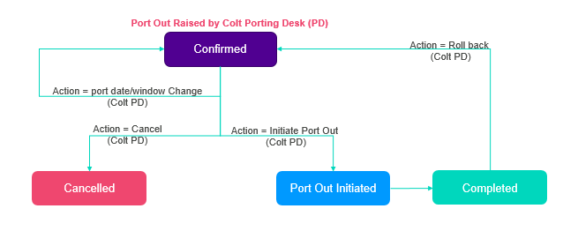

### Austria, Belgium, Switzerland

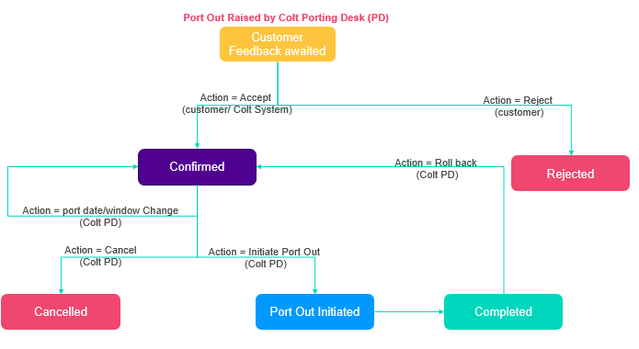

* Colt will automatically accept the port-out request if you fail to respond to the Port-Out request within the timelines below:

|  |  |
| --- | --- |
| *Country* | *Auto accept after N days of Port Out Order creation*  *(Excludes Bank holidays)* |
| *CH,BE* | *N=2* |
| *AT* | *N=5* |

* Daily reminders will be sent to you to accept the port out request once the order is created in “CFA” status.
* The Customer contact for porting is setup and maintained by the Reseller Support Voice team and will be used for these notifications. If you need to update your porting contact, please get in touch with [ResellerSupport.Voice@colt.net](mailto:ResellerSupport.Voice@colt.net)

### Germany

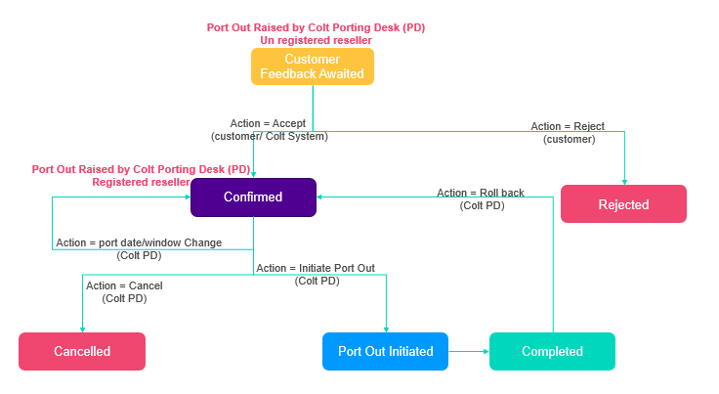

* Colt will automatically accept the port-out request if you fail to respond to the Port-Out request within the timelines below:

|  |  |
| --- | --- |
| *Country* | *Auto accept after N days of Port Out Order creation*  *(Excludes Bank holidays)* |
| *DE* | *N=5* |

* Daily reminders will be sent to you to accept the port out request once the order is created in “CFA” status.

The Customer contact for porting is setup and maintained by the Reseller Support Voice team and will be used for these notifications. If you need to update your porting contact, please get in touch with [ResellerSupport.Voice@colt.net](mailto:ResellerSupport.Voice@colt.net)

### Netherlands

When a port-out is raised for NL, instead of moving the order to Confirmation Awaited status, it will be moved to Customer Feedback Awaited status to align it with other countries.

Rest of the process remains unchanged.

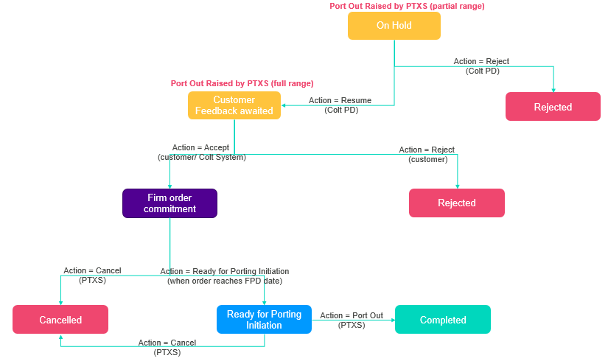

## Number Lifecycle for Port-out

In NOD UI and B2B APIs, new number statuses: Port Out In Progress, Transfer In Progress, Return In Progress will be available.

Please refer to the below sections for updated number lifecycle with new status for all countries except Germany. The number lifecycle for Germany will remain unchanged.

### Netherlands

#### Colt Owned Activated Numbers: Netherlands

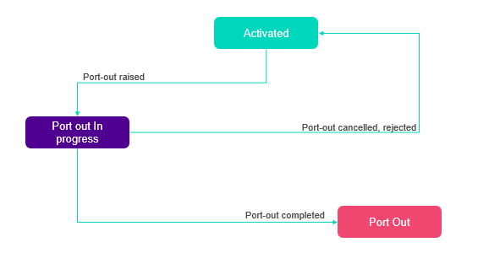

#### Ported-In Activated Numbers: Netherlands

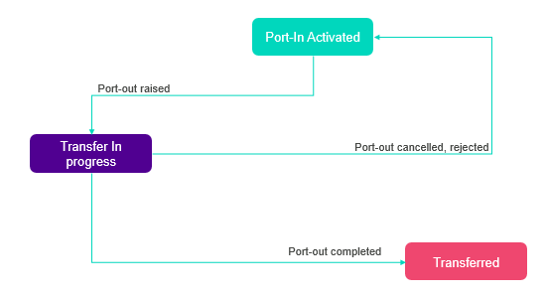

#### Colt Owned Quarantined Numbers: Netherlands

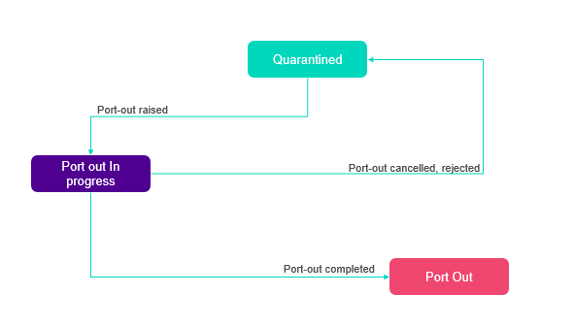

#### Ported-In Quarantined numbers: Netherlands

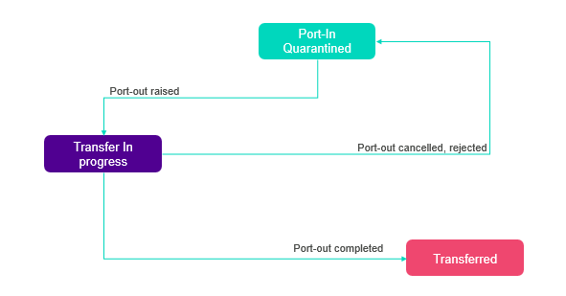

### Italy and Austria

#### Ported-In Activated Numbers

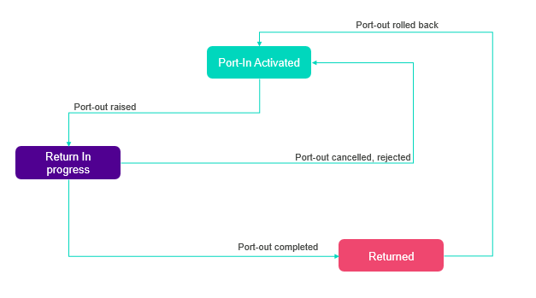

### All including Zone B countries, except NL and DE

#### Colt Owned Activated Numbers

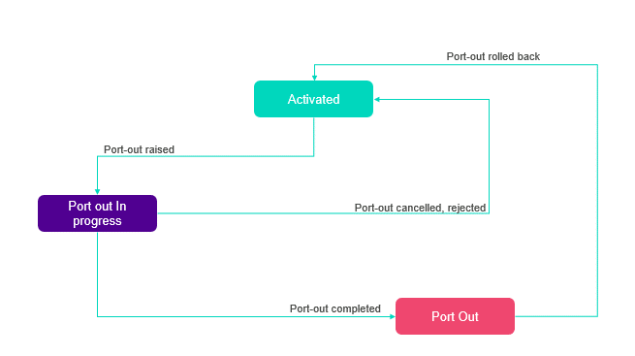

#### Colt Owned Quarantined Numbers

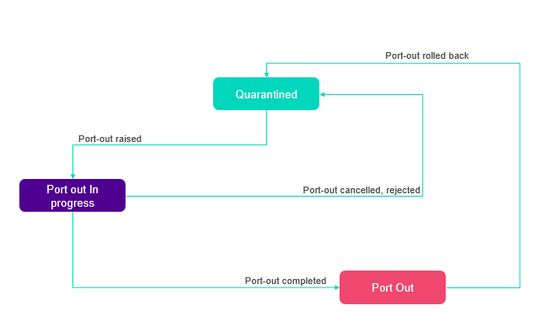

### All except NL, IT, AT, DE

#### Ported-In Activated Numbers

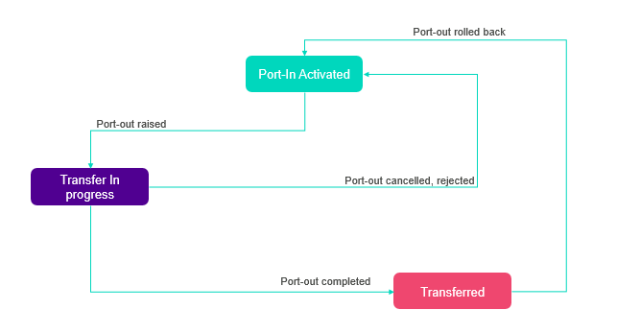

### France, Portugal, Spain, Switzerland

#### Ported-In Quarantined Numbers

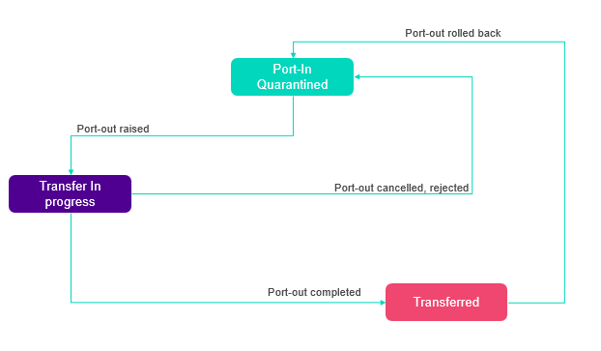

# Appendix A: XSD

The structure is updated in the XSD in these links: [link 1](https://344164.fs1.hubspotusercontent-na1.net/hubfs/344164/NH%20Release%20March%202023/NumberHostingServices_v3.16.xsd) and [link 2](https://344164.fs1.hubspotusercontent-na1.net/hubfs/344164/NH%20Release%20March%202023/nhm_cbe_v3.16-2.xsd)

# Appendix B: API specifications

## OAS Specification for NH APIs

Please click [here](https://344164.fs1.hubspotusercontent-na1.net/hubfs/344164/numberManagement_v2.0.4_12Dec2022.yaml) for the OAS Specification for Functional APIs

## OAS Specification for Address Management

Please click [here](https://344164.fs1.hubspotusercontent-na1.net/hubfs/344164/NH%20Release%20March%202023/addressManagement_v1.0.0_31Oct2022.yaml) for the OAS Specification for Address Management APIs

# Appendix C: Current Operator list

Please click [here](https://344164.fs1.hubspotusercontent-na1.net/hubfs/344164/NH%20Release%20March%202023/Current%20Operator%20List.xlsx) for the allowed current operator values for all countries except NL, DE and UK.