**Network Implementation Guide**

Colt Wholesale SIP (Number Hosting)

|  |
| --- |
| Copyright © Colt Group |
| No part of this document may be reproduced or adapted in any form, including photocopying or storing it by electronic means, except as is necessary for the purpose of the recipient's dealings with Colt, without the written permission of Colt. Any copies made of any part of this document shall include the notice:  © 2023 Colt Technology Services. The Colt name and logos are trademarks. All rights reserved. |
| No information contained in this document shall be disclosed to any third party without the written permission of Colt. |

[Document](file:///\\\\ULVMCTMFIL104\\DESKTOP104A\\YChoudhary\\Desktop\\guidesssssss\\Web_Manager_User_Guide_Number_Hosting_UK_v1.3.doc" \l "_Table_Of_Contens) History

Soft copies of this document are maintained under change control, but hard copies are not. This may not be a printout of the latest version.

**Revision history**

|  |  |  |
| --- | --- | --- |
| Revision | Date | Description |
| 1.0.0 | March 28, 2020 | Document creation following the split of network and API sections of ‘Colt Number Hosting Solution Guide v3.0’. |
| 1.0.1 | May 13, 2020 | Correction of ‘transcoding section for Fax’ |
| 1.0.2 | Oct 15, 2021 | Updates to the following:-  2.1 CLI lengths (Number format)  2.3 CLI policy  2.4 CLI screening  3.1 Signalling compliance  4.8 Call Admission Control  6.1 Resiliency Options  7.1.Emergency Service Numbers & Short Numbers dialling  7.2 Emergency Call Routing |
| 1.0.3 | Aug 8, 2022 | Updates to 2.3 CLI policy |
| 1.0.4 | Nov 21, 2022 | Updates to the following:  2.1 Number formats: Zone B countries  2.3 CLI policy: CLI Policy Profiles for Mobile  2.6 Country specific CLI Requirements  7.2 Emergency Call Routing (ECR): Added Zone B countries |
| 1.0.5 | Mar 22, 2023 | Updates to the following:  2.6 CLI Requirements  3.7 SIP Response Codes  7.2 Emergency Call Routing |
| 1.0.6 | Oct 11, 2023 | Updates to the following:  2.6.2 Impact of regulatory driven changes in France |
| 1.0.7 | Jan 24, 2024 | Updates to the following:  2.3 CLI policy  2.5 Calling Line Identification Restriction (CLIR)  2.6.2.2. CLI authentication in France  3.1 Signalling – update on supported RFCs  3.2 Transport types  3.6 DNS Resolution Support  3.7 Signalling Codes - ISUP CPC-to-SIP mapping removed  4.8 Call Admission Control – clarification on availability of shared CAC |
| 1.0.8 | Aug 30, 2024 | Updates to the following:  2.3 CLI policy & new sections 2.3.1 to 2.3.4 (clarification on surcharges)  2.6 New section on CLIP No Screening  2.7 Country specific CLI requirements (Regulatory) – updates for Belgium, Czech Republic, Poland, Switzerland  4.8 Call Admission Control (clarification on regulatory impacts)  7.2 Emergency Call Routing (clarification on Germany & Switzerland |
| 1.0.9 | Dec 20, 2024 | Updates to the following:  2.1 Number formats  2.7 Country specific CLI requirements (Regulatory)  3.7 New SIP response codes specific to CLI Authentication in France.  4.8 Addition of information on the Concurrent Call Pool (CCP)  7.2 Emergeny call routing – country update  Rebranding Number Hosting to Wholesale SIP |

Contents

[1. Document Scope 6](#_Toc188977464)

[2. Numbering & CLI Features 7](#_Toc188977465)

[2.1. Number formats 7](#_Toc188977466)

[2.2. SIP URI Format 8](#_Toc188977467)

[2.3. CLI policy and origin surcharging for outbound calls (You to Colt) 8](#_Toc188977468)

[2.3.1. Impacts of the CLI policy on how Colt bills origin surcharges 9](#_Toc188977469)

[2.3.2. Direct Call Scenario 9](#_Toc188977470)

[2.3.3. Call Forwarding Scenario 9](#_Toc188977471)

[2.3.4. Invalid Origin (invalid CLI) 9](#_Toc188977472)

[2.3.5. PANI – Mobile originated calls in France (You to Colt) 9](#_Toc188977473)

[2.4. CLI screening 10](#_Toc188977474)

[2.5. Calling Line Identification Restriction (CLIR) 10](#_Toc188977475)

[2.6. Calling Line Identification Presentation (CLIP) No Screening 10](#_Toc188977476)

[2.7. Country specific CLI requirements (Regulatory) 10](#_Toc188977477)

[2.7.1. Austria 10](#_Toc188977478)

[2.7.2. Belgium and The Netherlands 11](#_Toc188977479)

[2.7.3. Czech Republic, Finland, Luxembourg, Norway & Romania 11](#_Toc188977480)

[2.7.4. France 11](#_Toc188977481)

[2.7.5. Germany 14](#_Toc188977482)

[2.7.6. Ireland & UK 14](#_Toc188977483)

[2.7.7. Poland 14](#_Toc188977484)

[2.7.8. Spain 15](#_Toc188977485)

[2.7.9. Sweden 15](#_Toc188977486)

[2.7.10. Switzerland 15](#_Toc188977487)

[3. Signalling 16](#_Toc188977488)

[3.1. Standard Compliance 16](#_Toc188977489)

[3.2. Transport Types 17](#_Toc188977490)

[3.3. SIP Trunking Modes 17](#_Toc188977491)

[3.4. SIP Timers 18](#_Toc188977492)

[3.5. Session Timers 18](#_Toc188977493)

[3.6. DNS resolution Support 18](#_Toc188977494)

[3.7. SIP Response Codes 18](#_Toc188977495)

[3.7.1. SIP Response Codes for unsupported destinations 18](#_Toc188977496)

[3.7.2. SIP to ISUP CPC Mapping 18](#_Toc188977497)

[4. Bearer Services 21](#_Toc188977498)

[4.1. Codecs 21](#_Toc188977499)

[4.2. Media Path 21](#_Toc188977500)

[4.3. Transcoding 22](#_Toc188977501)

[4.4. Fax 22](#_Toc188977502)

[4.5. Modem 23](#_Toc188977503)

[4.6. DTMF 23](#_Toc188977504)

[4.7. Clear Channel 23](#_Toc188977505)

[4.8. Call Admission Control (CAC) 23](#_Toc188977506)

[4.9. Tones & Announcements 24](#_Toc188977507)

[4.10. Echo Cancellation 25](#_Toc188977508)

[4.11. Circular routing 25](#_Toc188977509)

[4.12. Call barring 25](#_Toc188977510)

[5. Access technologies 26](#_Toc188977511)

[5.1. Overview 26](#_Toc188977512)

[5.2. Internet 27](#_Toc188977513)

[5.3. IP VPN 27](#_Toc188977514)

[5.4. Quality of Service 28](#_Toc188977515)

[6. Resiliency options 29](#_Toc188977516)

[6.1. Overview 29](#_Toc188977517)

[6.2. Access Options 30](#_Toc188977518)

[6.2.1. Primary is Dedicated, Secondary is Internet 30](#_Toc188977519)

[6.2.2. Primary Dedicated, Secondary Dedicated 31](#_Toc188977520)

[6.2.3. Primary Internet, Secondary Internet 33](#_Toc188977521)

[6.3. Trunk Resiliency 35](#_Toc188977522)

[6.3.1. Call Routing 35](#_Toc188977523)

[6.3.2. Trunk Out of Service and Recovery Methods 35](#_Toc188977524)

[7. Emergency Service Numbers & Short Numbers calls 37](#_Toc188977525)

[7.1. List of supported numbers 37](#_Toc188977526)

[7.2. Emergency Call Routing (ECR) 38](#_Toc188977527)

[8. VoIP Performance Reporting 40](#_Toc188977528)

[**9.** **Glossary** 41](#_Toc188977529)

# Document Scope

This document provides you with further guidance and support for Colt’s Wholesale SIP Trunking service (previously known as Number Hosting) with on demand number management.

# Numbering & CLI Features

## Number formats

**Supported format**

All Numbers, e.g. Calling, Called and Redirecting Number, should be sent in E.164 international format **+<CC>NSN**, with:

* CC = Country Code,
* NSN = National Significant Number.

Please note there are exceptions for France as described in section x below.

**CLI length**

The table below provides an overview of the CLI length e.g. Austria has a minimum CLI length of 7 digits and a max CLI length of 17 digits. Calls which fail CLI length check will be blocked.

**Zone A Countries:**

| **Country  (Country Code)** | **CLI length (CCNSN) for National & EEA profiles** | **CLI length (CCNSN) for Global profile** |
| --- | --- | --- |
| **Austria (43)** | 7-15 | 7–15 |
| **Belgium (32)** | 10 | 10–15 |
| **Denmark (45)** | 10 | 10-14 |
| **France (33)** | 11 | 11-15 |
| **Germany (49)** | 7-17 | 7–17 |
| **Ireland (353)** | 10-12 | 10–15 |
| **Italy (39)** | 8-13 | 8–15 |
| **Netherlands (31)** | 11 | 9-13 |
| **Portugal (351)** | 12 | 12 |
| **Spain (34)** | 11 | 11-15 |
| **Sweden (46)** | 9-11 | 8-15 |
| **Switzerland (41)** | 11 | 11 |
| **United Kingdom (44)** | 11-12 | 9–12 |

**Zone B Countries:**

|  |  |
| --- | --- |
| Country (Country Code) | CLI length (CCNSN) |
| **Czech Republic (420)** | 12 |
| **Finland (358)** | 8-15 |
| **Luxembourg (352)** | 7-14 |
| **Norway (47)** | 10 |
| **Poland (48)** | 11 |
| **Romania (40)** | 11 |
| **Slovakia (421)** | 12 |

## SIP URI Format

Both **sip**: and **tel**: (RFC2806) URI formats are supported.

For SIP URI formats, the user part must be a valid telephone number in the format described in 2.1 OR ‘anonymous’. The user=phone parameter may or may not be included. The host part can be an IP address (of the SBC) or a domain name.

## CLI policy and origin surcharging for outbound calls (You to Colt)

For basic calls (i.e. normal outbound calls) a valid CLI populated with the customer number is expected in the PAI header. If the PAI header is not supported, a customer CLI can also be signalled in the FROM header (see 2.4).

For forwarded calls the Diversion header should be populated with the customer number, the FROM Header should contain the number of the original caller (Original Calling Number).

For all SIP Headers the format defined in 2.1 should be used

This is important as it defines the origin Colt will allow with the service and defines the level of risk for origin surcharges.

* **National Profile** (default): only allows calls originating from all in-country Fixed Line CLIs of the Trunk Group (TG) country.
* **National+Mobile Profile \***:only allows calls originating from all in-country Fixed and mobile CLIs of the Trunk Group (TG) country
* **EEA Profile**: only allows calls originating from the 13 Colt countries **(zone A)** Fixed Line CLIs
* **EEA+Mobile** **Profile \***: only allows calls originating from all in-country Fixed Line CLIs of the 13 Colt countries **(zone A)** and mobile CLIs of the TG country
* **Global Profile**: allows traffic originating from any origin excluding calls from +1 to +1. Measures to address misuse/spoofing of national CLIs may result in some in-country calls being restricted/blocked.
* **Global Profile RMD US**: allows traffic originating from any origin including calls from +1 to +1 (US traffic which requires customers to register in the US FCC’s RMD database and provide Colt with their FRN/registration number). Measures to address misuse/spoofing of national CLIs may result in some in-country calls being restricted/blocked.

In zone B countries, the **National profile** is the only possible profile applicable to zone B trunk groups:-

* Only allows calls originating from in-country Fixed Line CLIs which are activated/ported-in on the Trunk group in FI, & SK
* Allows calls originating from all in-country Fixed Line CLIs of the TG country in CZ, LU, NO, PL & RO (note Regulatory conditions apply in CZ & PL – see below)

For all profiles, the below traffic is blocked, where:

* No CLI is presented
* CLI length is invalid (i.e. not within defined number length of the country)
* The CLI contains alphanumeric (a-z, A-Z) or special characters (#, @ etc.)
* CLIs are in an invalid format, e.g. a country code is followed by ‘0’ in all zone A countries (except Italy because +390 is valid)
* CLIs are not assigned to any operator by a national Regulator

The SIP response code for calls blocked due to an invalid CLI is 403 (Forbidden) without announcement which gives you the benefit that you can crank back the call.

\* Please ask your Account Executive regarding SMS enabled mobile country coverage

### Impacts of the CLI policy on how Colt bills origin surcharges

|  |  |
| --- | --- |
| **CLI policy** | **Impact on how Colt bills origin surcharges** |
| **National profile & National+Mobile Profile** | These profiles are setup to avoid origin surcharges being applied, however this cannot be guaranteed as market/regulatory conditions may change. Advance notice of changes to pricing is given in accordance with the Wholesale SIP / Number Hosting service specific terms. Please refer to your Wholesale SIP / Number Hosting rate card. |
| **EEA profile & EEA+Mobile** **Profile** | This reduces the risk of surcharges but does not remove it completely as there are few low surcharge scenarios in the zone A countries. |
| **Global & Global Profile RMD US** | Includes call scenarios where origin surcharges may apply. |

### Direct Call Scenario

**CLI Policy, blocking rules & origin surcharges** are applied on the ‘trusted CLI’:

* If ‘PAI’ is available, the ‘trusted CLI’ will be the value received in the ‘PAI’ header.
* If ‘PAI’ is not available, the value received in ‘FROM’ will be treated as the ‘trusted CLI’.

### Call Forwarding Scenario

**CLI Policy, blocking rules & origin surcharges** are applied on the ‘received RDN’ (ReDirecting Number), i.e. calls will be blocked if the Diversion Header does not match the CLI Policy.

### Invalid Origin (invalid CLI)

It is common industry practice for higher surcharges (group D) to apply to calls where the calling line identifier (CLI) is invalid.

Although Colt blocks calls as described in the above CLI policy, we cannot guarantee that calls will not incur a surcharge due to an invalid CLI as a point of origin, which will incur the higher surcharge (group D). Examples include (please note this is not an exhaustive list):-

* If the trusted CLI length does not comply with the length in the national numbering plan
* If the trusted CLI has a prefix which is not allowed from a regulatory perspective in the national numbering plan e.g. the CLI is a Premium Rate or Shared Cost number

### PANI – Mobile originated calls in France (You to Colt)

In **France** you must provide a valid PANI (antenna location ID) for calls with a mobile CLI. Basic calls with French mobile CLIs with an invalid PANI will be surcharged.

In the case of call forwarding (i.e. Diversion header present) PANI is not required and there will be no origin surcharge for the forwarded call.

The PANI has a regulated format (9 digits):

* First two digits represent the Operator
* Next five digits represent the postal code of the mobile antenna
* Last two digits can be 00

## CLI screening

End-user provided CLI must be screened and validated by you. Colt will pass only those calls which fulfil the following requirements:

* SIP protocol: CLI signaled within PAI header.

If you do not support PAI you may also signal ‘trusted CLI’ in the FROM header if you guarantee a correct CLI. If FROM = anonymous then a valid CLI must be signalled in the PAI header (or alternate method of transmitting CLI compatible with the RFC).

## Calling Line Identification Restriction (CLIR)

You are responsible for providing the correct ‘CLIR’ information to Colt.

* SIP protocol**:** Colt support the following options to signal a CLI as restricted in a SIP INVITE:
* ‘Anonymous’ or ‘unknown’ or ‘restricted’ or ‘unavailable’ is set in one of the following fields: FROM Header, P-Preferred ID, P-Asserted ID or Remote Party ID and
* By inserting **P-Asserted-Identity** header and **Privacy: Id** header (RFC3323/3325)
* Valid CLI is set in another signaling field

Colt still need a CLI when you set any of the fields FROM Header, P-Preferred ID, P-Asserted ID and Remote Party ID to anonymous’ or ‘unknown’ or ‘restricted’ or ‘unavailable’.

## Calling Line Identification Presentation (CLIP) No Screening

You must configure your own services to comply with the regulatory conditions on how a presented CLI must be managed and shown to a called party – see here: [ww2.colt.net/CCP/CLIreq1/index.htm](http://ww2.colt.net/CCP/CLIreq1/index.htm). You are responsible for providing the correct ‘CLIP No Screening’ information to Colt. However Colt cannot guarantee the functionality across other carriers’ networks.

## Country specific CLI requirements (Regulatory)

Colt scan both the ‘PAI’ and ‘FROM’ fields in relation to the regulation regarding domestic/national calls. If either of the two fields signal a domestic origin of a call delivered over an international trunk, we apply the rules accordingly. For more details, please see the country information below.

### Austria

In Austria the regulatory conditions have been tightened and calls originating from Austria CLIs (+43) to Austrian national numbers (national calls) must be sent to Colt on your Austria SIP Trunk.

If Austrian national calls (CLI and Called Number = +43) are sent from a non-Austrian SIP trunk, then they will deemed to be as international origin and the CLI will be marked as international origin (‘P-Austria-Origin’ SIP Header) by Colt. On receipt of P-Austria-Origin SIP Header from Colt the PTT & OLOs may choose to take no action or anonymize the CLI or they may even block the call.

Colt will anonymize the CLI for national calls received with P-Austria-Origin from PTT&OLO or national calls from international origin which are terminated on Colt network (routed to customers). The same applies also for calls from Austrian national mobile numbers as well as forwarded / redirected calls, i.e. Colt will send P-Austria-Origin towards PTT&OLO and anonymize CLI for calls terminated on Colt network.

### Belgium and The Netherlands

As a result of misuse/spoofing of CLI’s telecom operators including Colt have implemented more measures in the network to prevent this.

**Blocking of calls from blacklisted CLIs received from an international origin in the Netherlands**

On request of NL authorities operators, including Colt, have implemented blocking of calls from abroad for a specific list of numbers, where the owner of the number has indicated that their number(s) will never be used as a CLI from abroad.

Calls from a CLI in this list sent on a non-NL trunk group will be deemed to be of international origin and will be blocked.

**Blocking of national/domestic calls originating internationally (Belgium)**

The regulatory conditions have been tightened in Belgium and calls originating from Belgium CLIs (+32) to Belgian national numbers (national/domestic calls) must be sent to Colt on your Belgium SIP Trunk.

If Belgian national fixed line calls are sent from a non-Belgian SIP trunk, then they will deemed to be of international origin and will be blocked. Calls from Belgian national mobile numbers as well as forwarded / redirected calls will have the CLI restricted / anonymized if they are received from an international origin.

### Czech Republic, Finland, Luxembourg, Norway & Romania

The regulatory conditions have been tightened in the Czech Republic and calls originating from Czech CLIs (+420) to Czech national numbers (national/domestic calls) must be sent to Colt on your Czech SIP Trunk.

If Czech national calls (CLI and Called Number = +420) are sent from a non-Czech SIP trunk, then they will deemed to be of international origin and will be blocked. Redirected/forwarded calls are an exception.

The same rules and logic apply in Finland, Luxembourg, Norway & Romania.

### France

#### Resale of Numbers

Since January 2023, the resale of numbers is now forbidden and all Operators are expected to source their own numbers and a porting/routing prefix from the regulator in FR (ARCEP) to provide services to their end customers. For more information on how Colt can host your own numbers and porting/routing prefix in France or use of an alternative tri-partite agreement, please contact your Colt Account Manager.

#### CLI Authentication

ARCEP, the regulator in France, introduced CLI authentication to protect called parties in 2H 2023.

CLI Authentication does not impact your existing Wholesale SIP Trunk unless you have own Number ranges from ARCEP and decide to sign & verify calls yourself in which case you should follow the rules provided by APNF and inform your Colt Account Manager so that your Wholesale SIP Trunk can be correctly configured.

There are other solutions where Colt can perform CLI authentication on your behalf – see below.

CLI Authentication means that:

* The calling party number contained in the **SIP From header** is authenticated by the operator originating the call.
* **Operators originating** outbound SIP calls to French numbers must **sign** calls with their certificate and indicate a level of attestation (A, B or C) indicating the level of trust (A is the most trustful), that the CLI is used by the end-customer to whom it has been allocated.
* **Operators terminating** inbound VoIP calls to French numbers must **verify** the signature in the call. When the verification fails, the call must be blocked by the terminating operator.
* Operators need to provide reports to the French operators association (APNF) which monitors the CLI Authentication mechanism across all French operators.

The technical specification for CLI Authentication has been defined by the French operators association (APNF) and, in phase 1, it has been decided not to consider the level of attestation to block calls. It will however be considered in a future phase and you will be notified.

**Wholesale SIP Customers with their own CLI Authentication solution**

Wholesale SIP customers with their own numbers hosted on Colt’s network can decide to sign and verify calls in their own network. If a customer has:-

* FR Trunk - all calls to any destination should be signed with the customer's direct certificate (as the signatory).
* Non-FR Trunk – calls should not be signed by customers. Calls to French destinations will be signed by Colt with Colt’s certificate.

In addition to the Number format defined in chapter 2.1, Wholesale SIP customers with their own CLI Authentication have to comply with these specific requirements:

French Short Numbers

Local-number format, as described in [RFC3966], must be used for national short codes (French specific non E.164 numbers: 10YT, 118XYZ, 116XYZ, 3BPQ) and the phone-context parameter should be set to +33.

Call direction Origination (Wholesale SIP to Colt)

|  |  |  |
| --- | --- | --- |
| **SIP Header** | **From** | **To / R-URI** |
| Format | Not supported | 3BPQ or 10YT or 118xxx or 116XYZ with Phone-context +33 |

Call direction Termination (Colt to Wholesale SIP)

|  |  |  |
| --- | --- | --- |
| **SIP Header** | **From** | **To / R-URI** |
| Format | FROM=3BPQ or 10YT with Phone-Context +33 | Not supported |

For example, 3610 short code will be conveyed in the Request-URI or From header as <tel:3610;phone-context=+33> or [sip:3610;phonecontext=+33@IP address;user=phone](sip:3610;phonecontext=+33@IP%20address;user=phone).

DROM numbers (French Oversea Territories)   
DROM Numbers in From, To and R-URI must be sent with a valid DROM country Code (and not+33) e.g. FROM=+590xxxxxxxxx

DROM Country Code List

+590 Guadeloupe, Saint-Martin et Saint-Barthélemy

+594 Guyane

+596 Martinique

+262 La Réunion, Mayotte and other French territories of the Indian Ocean

+508 Saint-Pierre-et-Miquelon

**Wholesale SIP Customers without their own CLI Authentication solution**

If a Wholesale SIP customer is not signing & verifying calls themselves, there are these other solutions:-

By default, Colt support CLI authentication **on behalf** of customers **using Colt numbers only** and numbers ported-in to Colt. Colt signs calls with Colt’s own certificate and verifies calls in Colt’s name. The level of attestation is defined by Colt as described in Q&A in English [here](https://eur01.safelinks.protection.outlook.com/?url=https%3A%2F%2F344164.fs1.hubspotusercontent-na1.net%2Fhubfs%2F344164%2FCLI%2520authentication%2520in%2520France%2520QA%2520v2.2.pdf&data=05%7C01%7COlivia.Mcdonald%40colt.net%7C172cc78d2c964a3d7a3708db6d7e1586%7Cb859cf7eff8a40bbbd0fda56e6dc0eb8%7C1%7C0%7C638224160552255277%7CUnknown%7CTWFpbGZsb3d8eyJWIjoiMC4wLjAwMDAiLCJQIjoiV2luMzIiLCJBTiI6Ik1haWwiLCJXVCI6Mn0%3D%7C3000%7C%7C%7C&sdata=YuSHdXhxuORVI2G%2F1Yxj3YU6CJFfYz5lzl2f%2BfCnflk%3D&reserved=0).

Colt can support CLI authentication **on behalf** of customers, who are:-

* **using their own numbers only, which are hosted in Colt network** and their ported-in numbers, or
* are **using both Colt and their own numbers hosted in Colt network**, Colt ported-in numbers and their ported-in numbers. In that case Colt sign and verify calls on behalf of a customer with the customer’s certificate, and/or
* **are sending/least cost routing calls to Colt** from **non-Colt FR numbers.**

To allow Colt to sign and verify calls on behalf of a customer, a customer must:-

* register with APNF,
* sign the Colt TSO/TVO mandate to mandate Colt as their OPTS (Technical Signing Operator)/ OPTV (Technical Verification Operator)
* get their own indirect certificate with APNF that Colt uses to sign ALL calls terminating in France from any origin

For those customers who only **send calls to France from non-FR CLIs**, then Colt will act as an international gateway and will sign ALL calls to France with Colt’s certificate and attestation level C.

**Trace and Volumetrics reports**

If you have mandated Colt as your OPTS/TSO, then Colt will provide trace and volumetrics reports to APNF on your behalf. You can have access to trace and volumetrics data on the MAN portal under the respective menus MAN Metrics: Breakable/Broken Calls (trace) and Statistics (Volumetrics) – see snapshot below.

Please refer to APNF operational guide for more details.

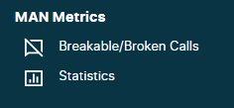

The level of attestations for the above solutions are defined by Colt and are described in Q&A in [English](https://eur01.safelinks.protection.outlook.com/?url=https%3A%2F%2F344164.fs1.hubspotusercontent-na1.net%2Fhubfs%2F344164%2FCLI%2520authentication%2520in%2520France%2520QA%2520-%2520EN.pdf&data=05%7C01%7CSophie.Bercovici%40colt.net%7C8fc68db208f946276a9608db5dd4310f%7Cb859cf7eff8a40bbbd0fda56e6dc0eb8%7C1%7C0%7C638206938193032020%7CUnknown%7CTWFpbGZsb3d8eyJWIjoiMC4wLjAwMDAiLCJQIjoiV2luMzIiLCJBTiI6Ik1haWwiLCJXVCI6Mn0%3D%7C3000%7C%7C%7C&sdata=7jiev31TPhMWYnBu%2BNMWDWJmRsiAyr96xdLsc7T8%2BF0%3D&reserved=0).

Note that outbound calls which originate from non-Colt numbers or non-Customer own hosted numbers are signed with a lower attestation level.

As per APNF’s decision for phase 1, the terminating operator is not allowed to communicate the result of the verification to the end-customer (neither verstat nor attestation level).

To conclude, CLI Authentication does not impact your existing Wholesale SIP Trunk unless you have your own Number ranges and decide to sign & verify calls yourself.

#### Calls from automated systems in France

The numbering plan update from ARCEP here:- [www.arcep.fr/uploads/tx\_gsavis/22-1583.pdf](http://www.arcep.fr/uploads/tx_gsavis/22-1583.pdf) states that 10-digit geographic, nomadic and mobile numbers must NOT be used as CLI presentation when the call originates from an automated system, effective from 1 January 2023.

Calls originating from an automated system can only originate from verified nomadic numbers, i.e. in mainland France from these new defined ranges: 0162, 0163, 0270, 0271, 0377, 0378, 0424, 0425, 0568, 0569, 0948 to 0949.

ARCEP sets out the conditions regarding the usage of such numbers:-

* You must be able to verify and guarantee to the authorities and any Voice operator in France that the use of the number has received the prior explicit agreement of the assignee of that number (e.g. a call centre’s client’s explicit agreement) in order for that number to be used as CLI presentation in each call or message in which it appears
* Otherwise you must prevent or block the call or message from originating from that number as CLI presentation (in the FROM field of the SIP header), even if CLI presentation masking is applied to that call or message

If you wish to support end-customers who make calls from automated systems then:

* As a reseller in France, you should apply to ARCEP for your own nomadic number blocks out of the following ranges: 0162, 0163, 0270, 0271, 0377, 0378, 0424, 0425, 0568, 0569, 0948 to 0949 and request Colt host these number blocks on your behalf and then assign these numbers to your end-customers for this specific use
* If you are a direct call centre and not a reseller, you should contact your Account Manager to review your requirements and eligibility to acquire Colt verified nomadic numbers. Considering ARCEP’s usage conditions applicable to those numbers, Colt’s provision of those are subject to specific contractual, operational & technical conditions

### Germany

In Germany the regulatory conditions have been tightened and calls originating from Germany CLIs (+49) to German national numbers (national calls) must be sent to Colt on your Germany SIP Trunk.

If German national calls (CLI and Called Number = +49) are sent from a non-German SIP trunk, then they will deemed to be of international origin and CLI will be restricted.

### Ireland & UK

As a result of misuse/spoofing of CLI’s telecom operators including Colt have implemented more measures in the network to prevent this.

**Blocking of calls from blacklisted CLIs (DNO = Do Not Originate)**

On request of the Irish and UK authorities, operators including Colt, have implemented blocking of calls from abroad for a specific list of numbers, where the owner of the number has indicated that their number(s) will never be used as a CLI from abroad.

Calls from a CLI in this list sent on a non-IE or non-UK trunk group will be deemed to be of international origin and will be blocked.

**Blocking of national/domestic calls originating internationally**

The regulatory conditions have been tightened in Ireland and the UK and calls originating from Ireland CLIs (+353) to Irish national numbers (national/domestic calls) must be sent to Colt on your Ireland SIP Trunk and calls originating from UK CLIs (+44) to UK mainland national numbers (national/domestic calls) must be sent to Colt on your UK SIP Trunk.

If Ireland national calls (CLI and Called Number = +353) are sent from a non-Irish SIP trunk and UK national calls (CLI and Called Number = +44) are sent from a non-UK SIP trunk, then they will deemed to be of international origin and will be blocked. Redirected/forwarded calls are an exception. The treatment of mobile calls in Ireland is under discussion at an industry level and a solution needs to be in place for Jan 2026.

### Poland

**Blocking of calls from blacklisted CLIs received from an international origin**

On request of PL authorities operators in Poland have implemented blocking of calls from abroad for a specific list of numbers, where the owner of the number has indicated that their number(s) will never be used as a CLI from abroad.

Calls from a CLI in this list sent on a non-PL trunk group will be deemed to be of international origin and will be blocked.

**CLI restriction of national/domestic calls originating internationally**

The regulatory conditions have been tightened in Poland and calls originating from Poland CLIs (+48) to Polish national numbers (national/domestic calls) must be sent to Colt on your Polish SIP Trunk.

If Polish national calls (CLI and Called Number = +48) are sent from a non-Polish SIP trunk, then they will deemed to be of international origin and will be restricted / anonymized. An exception is redirected/forwarded calls.

### Spain

**Blocking of national/domestic calls originating internationally**

It is anticipated that from July 2025, the regulatory conditions will be tightened in Spain and calls originating from Spain CLIs (+34) to Spanish national numbers (national/domestic calls) must be sent to Colt on your Spanish SIP Trunk.

If Spanish national fixed line calls are sent from a non-Spanish SIP trunk, then they will deemed to be of international origin and will be blocked.

### Sweden

**Blocking of national/domestic calls originating internationally**

The regulatory conditions have been tightened in Sweden and calls originating from Sweden CLIs (+46) to Swedish national numbers (national/domestic calls) must be sent to Colt on your Sweden SIP Trunk.

If Swedish national fixed line calls are sent from a non-Swedish SIP trunk, then they will deemed to be of international origin and will be blocked. Forwarded / redirected calls will have the CLI restricted / anonymized if they are received from an international origin. From Mar 2025 calls from Swedish national mobile numbers should be blocked if the caller is not roaming.

### Switzerland

Wholesale SIP customers must ensure they indicate in their order for a Swiss SIP trunk that it was must be ordered & provisioned in-country if they plan to offer numbers/services to Swiss financial institutions in accordance with the Finma guidelines.

**CLI restriction of national/domestic calls originating internationally**

In Q125 the regulatory conditions will be tightened and calls originating from Switzerland CLIs (+41) to Swiss national numbers (national calls) must be sent to Colt on your Switzerland SIP Trunk.

If Swiss national calls (CLI and Called Number = +41) are sent from a non-Swiss SIP trunk, then they will deemed to be of international origin and the CLI will be restricted by Colt. The PTT & OLOs may choose to take no action (i.e. route the call to the called party with the CLI restricted) or they may block them.

# Signalling

## Standard Compliance

The service is compliant with the following standards for basic SIP interoperability:

|  |  |
| --- | --- |
| RFC | Description |
| RFC 3261 | SIP |
| RFC 3264 | Offer/Answer |
| RFC 3311 | UPDATE |
| RFC 3262 | 100rel / PRACK (configurable per trunk) |
| RFC 4028 | SIP Session Timers (configurable per trunk, INVITE or UPDATE method) |
| RFC 3323/3325 | SIP Privacy extensions (Privacy/P-Asserted-Id) |
| RFC 5806 | Diversion Header |
| RFC 4244 | History-Info\* |
| RFC 3515 | SIP REFER\* |
| RFC 3892 | Referred-By Header\* |
| RFC 3326 | SIP Reason Header |
| RFC 2327 | Session Description Protocol (SDP) |
| RFC 2782 | Describes a DNS RR which specifies the location of the server(s) for a specific protocol and domain.\* |
| RFC 2806 | URLs for Telephone Calls\* |
| RFC 2976 | SIP INFO Method |
| RFC 3311 | SIP UPDATE Method |
| RFC 3362 | Real-time Facsimile (T.38) - image/t38 MIME Sub-type Registration |
| RFC 4028 | Session Timers in SIP |
| RFC 4474 | Authenticated Identity Management |
| RFC 7433 | Call control UUI data |

*\*Restrictions apply*

**Other Specifications**

SIP-ISUP interworking according to ITU-T Q.1912.5 and RFC 3398

SIP Connect 1.0 – Compliant

SIP Connect 1.1 – Partially Compliant

* Registration mode is not supported.
* TLS is optional (not mandatory).

**The following RFCs are not supported**:

* RFC 4967 (Dial string URI parameter),
* RFC 5031 (Emergency services URN),
* RFC 5280 (X.509 PKI CRLs),
* RFC 6140 ("Registration for Multiple Phone Numbers),
* RFC 5876 (Updates to Asserted Identity in the SIP protocol),
* RFC4566 (RFC2327 SDP is supported)

**Supported SIP Methods**

|  |  |
| --- | --- |
| Method | Supported? |
| **INVITE** | YES |
| **ACK** | YES |
| **BYE** | YES |
| **CANCEL** | YES |
| **UPDATE** | YES |
| **PRACK** | YES |
| **OPTIONS** | YES |
| **REGISTER** | NO |
| **SUBSCRIBE** | YES\* |
| **NOTIFY** | YES \* |
| **INFO** | YES \* |
| **REFER** | YES \* |

*\*Supported but normally not used and not used as part of standard product feature set*

## Transport Types

The following SIP transport types are supported:

* SIP-TCP (Port 5060)\*
* SIP-UDP (Port 5060)\*
* SIP-TLS (Port 5061)

The TCP/UDP port is fixed on the SBC but can be customized for requests sent towards the customer

The maximum SIP PDU size is 6 K bytes .

\*Colt can support other than 5060 as signalling port for receiving SIP signalling, however this will be bespoke configuration.

Note: Colt can support any signalling port towards customer SIP equipment

## SIP Trunking Modes

Wholesale SIP supports **Static Mode** SIP trunking whereby a SIP trunk is established between a fixed source and destination IP address on the Colt SBC and Customer VoIP platform.

**Registration Mode**, where the VoIP platform registers to the network and does not require fixed source IP address, is currently **not supported.**

## SIP Timers

SIP Timers protocol retransmission timers are set to the default values recommended in RFC3261 – T1=500ms, T2=4000ms.

The INVITE retransmission, Timer B, applicable for SIP-UDP, is set to T1\*64 by default. For resilient services it is reduced to T1\*3=1.5s (1 retransmission).

An answer supervision timer is set to 300s on Colt gateways (timeout for interval between first 18x and the call being answered). Note that it is possible that calls may be released earlier by an answer timeout elsewhere in the network.

The Long Duration Call timer is set to 2880mins (48hrs).

## Session Timers

By default, SIP Session Timers (RFC4028) are supported using the Re-INVITE method and Session-Expires 1800s (30mins) and MinSE=90s. If the session refresh causes issues e.g. call dropped or muted it can be disabled on request.

Note that the customer VoIP platform does not need to support Session Timers (Colt SBC will act as Refresher in this scenario).

## DNS resolution Support

In general, sending or receiving Fully Qualified Domain Names (FQDN) in SIP messages is not supported - FQDNs will not be resolved to an IP address or vice versa.

The host portion of SIP URIs contained in SIP headers used for routing of SIP messages (e.g. Request-URI, Contact, Record-Route, via, and Route headers) MUST contain numeric IPv4 addresses. FQDNs in other URIs of a SIP message will be ignored.

DNS support for resolving FQDNs based on RFC 3263 (Locating SIP Servers) may be possible as part of a bespoke design.

## SIP Response Codes

### SIP Response Codes for unsupported destinations

Destination codes not supported by Colt due to regulatory or commercial reasons will be blocked with SIP Response 503 ‘Service Unavailable’.

### SIP to ISUP CPC Mapping

|  |  |  |  |
| --- | --- | --- | --- |
| SIP | Definition | ISUP | Crank back[[1]](#footnote-2) |
| **400** | Bad Request | 41 | YES |
| **401** | Unauthorized | 21 |  |
| **400** | Bad Number Format | n.a. |  |
| **402** | Payment Required | 21 |  |
| **403** | Forbidden | 21 |  |
| **403** | Stale Date | n.a. | **2** |
| **404** | Not Found | 1 |  |
| **405** | Method Not Allowed | 63 |  |
| **406** | Not Acceptable | 79 |  |
| **407** | Proxy Authentication Required | 21 |  |
| **408** | Request Timeout | 102 |  |
| **409** | Conflict | 41 | YES |
| **410** | Gone | 22 |  |
| **411** | Length Required | 127 |  |
| **413** | Request Entity Too Large | 127 |  |
| **414** | Requested URL Too Large | 127 |  |
| **415** | Unsupported Media Type | 79 |  |
| **416** | Unsupported URI1 Scheme | 127 |  |
| **420** | Bad Extension | 127 |  |
| **421** | Extension Required | 127 |  |
| **423** | Interval Too Brief | 127 |  |
| **428** | Use Identity Header | n.a. |  |
| **436** | Bad Identity Info | n.a. | **2** |
| **437** | Unsupported Credential | n.a. | **2** |
| **438** | Invalid Identity Header | n.a. | **2** |
| **480** | Temporarily Not Available | 18 |  |
| **481** | Call Leg or Transaction Does Not Exist | 41 | YES |
| **482** | Loop Detected | 25 |  |
| **483** | Too Many Hops | 25 |  |
| **484** | Address Incomplete | 28 |  |
| **485** | Ambiguous | 1 |  |
| **486** | Busy Here | 17 |  |
| **487** | Request Terminated | 31 |  |
| **488** | Not Acceptable Here | 31 |  |
| **500** | Internal Server Error | 41 | YES |
| **501** | Not Implemented | 79 |  |
| **502** | Bad Gateway | 38 | YES |
| **503** | Service Unavailable | 41 | YES |
| **504** | Server Timeout | 102 |  |
| **505** | SIP Version Not Supported | 127 |  |
| **513** | Message Too Large | 127 |  |
| **600** | Busy Everywhere | 17 |  |
| **603** | Decline | 21 |  |
| **604** | Does Not Exist Anywhere | 1 |  |
| **606** | Not Acceptable | 31 |  |
| **N/A** | Internal: No Route to Specified Network | 2 | YES |
| **N/A** | Internal: No Route to Destination | 3 | YES |
| **N/A** | Internal: No Circuit Available | 34 | YES |
| **N/A** | Internal: Switching Equipment Congestion | 42 | YES |
| **N/A** | Internal: INVITE Request timeout/IP Address unreachable | 151 | YES |

|  |  |
| --- | --- |
| **SIP reject code** | **SIP reject sub-code** |
| 400 | Bad Number format |
| 403 | Stale Date |
| 428 | Use Identity Header |
| 436 | Bad Identity Info |
| 437 | Unsupported Credential |
| 438 | Invalid Identity Header |

Call will be re-routed to an alternate SIP trunk if available

2 Specific to STIR/SHAKEN (CLI Authentication France)

# Bearer Services

## Codecs

The following audio codecs are supported. Please note that not all codecs are enabled by default.

The far right column describes whether it’s possible to transcode to other codecs e.g. G.729a to G.711 if there is a codec mismatch.

|  |  |  |  |  |
| --- | --- | --- | --- | --- |
|  | Codec | Sample Size | Enabled by Default? | Transcode Support? |
| 1 | G.729A | 20ms | YES | YES |
| 2 | G.711alaw | 20ms | YES | YES |
| 3 | G.726 (32Kbps) | 20ms | YES | YES |
| 4 | G.722 | 20ms | NO | YES |
| 6 | G.711ulaw | 20ms | NO | YES |
| 7 | iLBC (15.2Kbps)\* | 20ms\* | NO | YES |

*\* iLBC can fallback to lower bit rate 13.33Kbps/30ms depending on mode parameter in offer/answer*

|  |  |
| --- | --- |
| *http://downloadicons.net/sites/default/files/warning-sign-icon-63117.png* | *Transcoding is an optional and chargeable feature, disabled by default, allowing customer to connect equipment that supports only a limited set of codecs.* |

Silence suppression and comfort noise based on RFC3389 (for codecs that do not support discontinuous transmission) are not enabled by default.

Video codecs are currently not supported.

|  |  |
| --- | --- |
| *http://downloadicons.net/sites/default/files/warning-sign-icon-63117.png* | *In order to ensure 100% successful IP to IP calls, customer must support G711Alaw 20ms codec as a fall-back. If customer cannot support the G711Alaw codec then Colt can provide a transcoding capability, this is a chargeable feature. If neither of above requirements are met, customer takes the risk of having IP to IP call failures.* |

**RTCP**

RTCP is disabled by default. RTCP-XR is not supported.

## Media Path

RTP ports used on the Colt SBC are dynamically allocated from **UDP port range** **1024 to 65534** excluding ports 5060/5061 which are reserved for signalling. This is a global setting and cannot be adapted per trunk. There is no restriction on peer RTP port range.

The media path for IP-IP calls between trunks is always anchored at the SBC. Media bypass (also known as media optimization or direct media) where the media path is established directly between customer endpoints, is **not supported**.

For security, by default, if the source IP address of incoming RTP packets differs from the outbound RTP IP address (negotiated in the SDP Offer/Answer), the traffic will be discarded by the Colt SBC (resulting in one-way audio). This feature can be disabled on request.

* Media IP addresses are negotiated during call setup
* On the SBC, one or more IP addresses are allocated for media. Media addresses are separate from signaling addresses but are in the same subnet and VLAN.

## Transcoding

Transcoding is an optional and chargeable feature, disabled by default, allowing customer to connect equipment that supports only a limited set of codecs.

Transcoding involves translating the media stream from one encoding format on ingress, to another encoding format on egress and vice versa. Transcoding ensures that calls can be established even when there is no common end-to-end codec.

* **Transcoding will only be required where the customer has endpoints that do not support G.711alaw (either 1st choice codec or as a fall back).**
* It only applies to IP-to-IP call flows (see exceptions below).
* When transcoding is enabled, it is applied selectively, on a call-by-call basis.
* Transcoding only occurs as a last resort when the network and endpoints cannot agree a common codec end- to-end. Usually, this occurs regardless of codec priorities configured in the network and on the endpoints (see exceptions below).
* Transcoding consumes additional DSP resources on the SBC and is only configured when explicitly required

When the codec list on a trunk is customized (codecs removed or added) selective transcoding is enabled by default for all codecs apart from G.711alaw.This is done to ensure interoperability with other endpoints in the Colt network.

**Transcoding for Fax**

Transcoding for fax will not be configured since in most cases fall back from T.38 to G.711 will work.

**Transcoding for DTMF and sample size**

In some cases, a mismatch of DTMF or sample size encoding may cause a less preferred codec to be selected or a call to fail. In this case, manually configure ‘Different DTMF Relay’ or ‘Different Packet Size’.

## Fax

Group 3 Fax (V.27 ter, V.29, and V.17) is supported using the T.38 protocol. Typically, the answer side will detect the Fax tone (2100Hz CED answer tone) and initiate a Re-INVITE for T.38. Fallback to G.711 is also supported for endpoints that do not support T.38.

Super Group 3 (V.34) is detected as modem call and will use G.711 pass-through.

Fax ECM (Error Correction Mode) is disabled by default (requires additional DSP resources) but can be enabled on request.

For VoIP platform that only support G.711 Fax pass-through, **fax transcoding** (G.711 óT.38) can be enabled to ensure interoperability.

|  |  |
| --- | --- |
| *http://downloadicons.net/sites/default/files/warning-sign-icon-63117.png* | *T.38 protocol is supported on a best effort basis. In order to insure 100% successful Fax transmission, customer must support G711 codec as a fallback.* |

## Modem

Modem Pass-through (V.34) is supported with codec up-speed to G.711 using Re-INVITE.

Echo cancellers and Non-linear processing are disabled on detection of a 2100Hz phase reversing modem tone.

## DTMF

Out-of-band DTMF is supported using RFC4733 (updates RFC2833) which defines the RTP Payload for DTMF Digits, Telephony Tones and Telephony Signals. The default payload type is 101.

Colt does not modify payload type sent from other carriers. If customer requires a particular payload type for all calls, transcoding will be applicable. Transcoding is a chargeable service.

Use of RFC4733 avoids distortion that may be caused by compressed audio codecs and avoids signalling path delay associated other out-of-band DTMF techniques such as SIP INFO.

|  |  |
| --- | --- |
| *http://downloadicons.net/sites/default/files/warning-sign-icon-63117.png* | *DTMF using SIP INFO is not recommended and supported only on a best effort basis.* |

## Clear Channel

64k unrestricted data channel over RTP can be supported using RFC4040 (Clear mode). The default payload type is 125 Caveats.

Customer endpoints need an accurate clock source to prevent bit errors.

Clear Channel does not work with applications that require channel bonding e.g. ISDN video.

## Call Admission Control (CAC)

Call Admission Control (CAC) defines the maximum call rate and maximum number of concurrent calls that can be supported on a trunk.

The **call-limit is applied based on the information specified by the customer** in the EOF.

There are configurable options as illustrated here:-

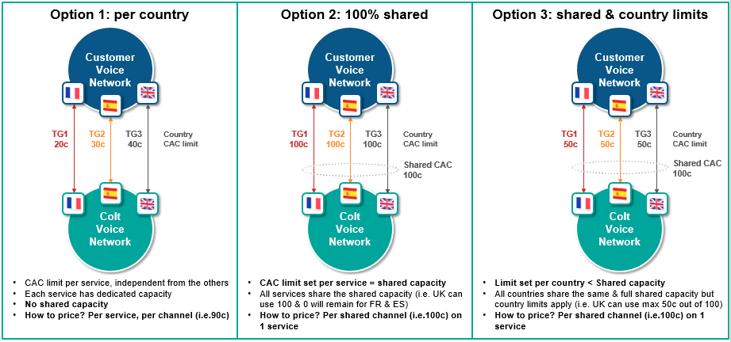

There is also a default call rate limit (CRL) of **10 call attempts per sec** (CAPS), **5** in France.

When the call limit or CRL is exceeded on a trunk, the Colt SBC returns a **Q.850 release cause 34** or **SIP 503 service unavailable** error response.

When the call limit is exceeded and resilient trunks are available, calls may overflow onto the other trunks, i.e. shared CAC is only supported for trunks hosted on the same Colt SBC (no POP resiliency).

The call rate limiting uses a token bucket policer which allows the call rate to temporarily burst above the defined limit. Only the calls that exceed the limit are dropped and there is no temporary lockout.

Please note that **national/domestic calls which overflow to other country SIP trunks may be blocked as a result of national regulation**. National/domestic calls should only be routed to the specific national/in-country SIP trunk(s) – see section 2.7.

Please note the **zone B countries are out of scope of the pricing offer for options 2 & 3.**

**Concurrent Call Pool (CCP) – Shared CAC**

Apart from call admission control, this feature will allow to configure combined CAC limit among the two or more Trunks configured in the same SBC. Shared pool CAC limit and individual CAC limit together will decides number of call allowed through the trunk. E.g Shared pool limit is assigned as 15, between two trunks and individual call limit is 10, then concurrent calls between two trunk will not exceed 15 and for single trunk there will not be more than 10 calls are permitted.

## Tones & Announcements

**Local Ring-Back tone**

It is customer responsibility to provide local ring-back tone.

Colt is acting as a transit provider and consequently for calls towards the customer local ring-back tones to calling party has to be provided by the customer (or end-customer PBX) upon receipt of an alert indication without a media stream or without an indication of in-band tones e.g. 18x with no SDP.

**SIP Response code for failed calls**

Please refer to 3.7 SIP Response Codes .

## Echo Cancellation

VoIP Gateways are equipped with ITU G.165 compliant echo cancellers. These are configured globally (cannot be adjusted per trunk) with an echo tail of 128ms.

## Circular routing

All traffic, being sent from Colt to you, must be terminated within your network and not send back to Colt, unless it is call forwarding.

## Call barring

Colt does not offer any call barring services per your end-customer individual request. There will be no CLI (per end-customer) related (un)blocking possible.

# Access technologies

## Overview

The figure below describes the high level network setup and IP addressing between the Colt VoIP POP and customer equipment.

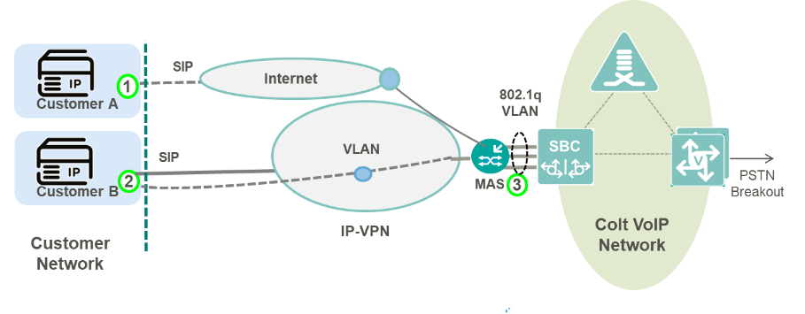

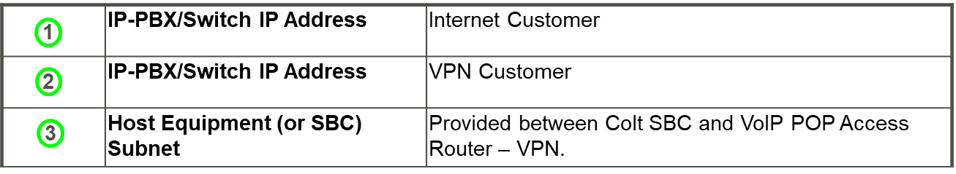

*Wholesale SIP IP Addressing*

For all types of access technology, the following IP address information is required to setup a Wholesale SIP trunk:

* **IP-PBX/Switch IP Address** - The host IP address that initial SIP Requests are sent to.
* **IP-PBX/Switch IP Range** - The host or subnet from which SIP requests/responses may originate in the customer network (often the same as IP-PBX IP Address).

Both of these addresses must be reachable from the Colt SBC i.e. routable over the Internet, IP-VPN.

Any subnets used to terminate RTP media e.g. phones, music-on-hold server, conference servers etc. must also be reachable from the Colt SBC. Additional IP addressing may be required depending on the access type used. These are described below.

## Internet

Colt VoIP POPs are connected to the Colt Internet backbone and allows trunks to be established over the public Internet. A set of shared signalling and media public IP addresses are configured on each SBC and are reachable from the Internet.

**Colt SBC IP Addressing**

Each VoIP POP is configured with Public IPv4 subnet used for Internet connected trunks. Each SBC is configured one or more public SIP signalling and media IP addresses which are shared by all customers and trunks.

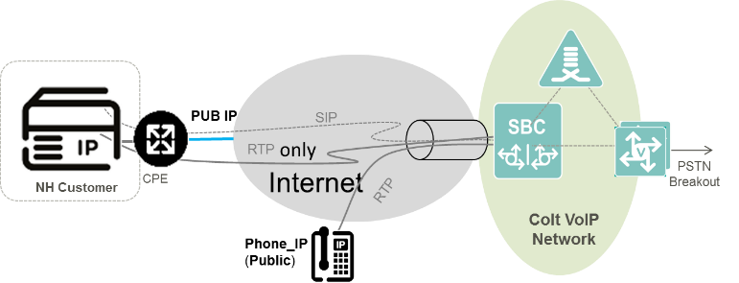

*NAT Traversal*

## IP VPN

Connectivity to customers with IP VPN makes use of the MPLS enabled access switches in Colt VoIP POPs. The Customer IP VPN is terminated on the access switch and presented on a dedicated VLAN interface towards the SBC.

A **Host Equipment Subnet** is configured between the SBC and the access switch which hosts the SIP signaling and media addresses that the customer uses to connect to the VoIP POP from their VPN.

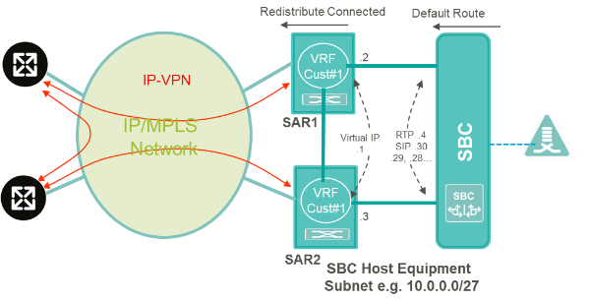

*VoIP POP Configuration for IP-VPN*

The **Host Equipment Subnet** is allocated a /27 IP Address range from the customer’s address space. This is typically an RFC1918 private address range that is routable from the customer a network. The subnet should be a /27 due to a design constraint on the Colt SBC.

|  |  |
| --- | --- |
| *http://downloadicons.net/sites/default/files/warning-sign-icon-63117.png* | * *The one exception is where public IP addresses are used in which case there are no restrictions on the subnet mask.* * *The design constraint requires that all (potentially) overlapping subnets (across different customers on the SBC) must use the same subnet mask. The subnet size has been standardized to /27 for this purpose.* |

If multiple trunks are required on the same SBC e.g. for resiliency or multi-country support, **up to 26 trunks** can be setup with separate SIP signalling IP addresses on the SBC sharing the same customer signalling IP address.

For each additional POP, or if more than 26 signalling IP addresses are required on the same POP, a separate /27 subnet is required.

**SBC Host Equipment Subnet IP Address Allocation e.g. 10.0.0.0/27.**

|  |  |  |
| --- | --- | --- |
| First Useable IP | SBC NEXT HOP | .1 |
| Second Useable IP | RESERVED | .2 |
| Third Useable IP | RESERVED | .3 |
| Fourth Useable IP | SBC MEDIA / INTERFACE ADDRESS | .4 |
| Last Non Broadcast IP N | 1st SBC SIP SIGNALLING ADDRESS | .30 |
| N-n | nth SBC SIP SIGNALLING ADDRESS (1 ≤ n ≤ 26) | . (31-n) |

## Quality of Service

The Colt VoIP network supports Diffserv QoS marking for VoIP traffic. Voice payload is marked with DSCP 46 (EF) and signalling with DSCP 26 (AF31). This allows voice payload and signalling traffic priority over other kinds of traffic across the Colt IP backbone and customer access circuit. The DSCP markings correspond to the Premium and Business-1 Class of Service used with the existing COLT IP VPN product.

**DSCP Markings**

|  |  |  |
| --- | --- | --- |
| Class of Service | DSCP Marking (code point name) | IP VPN CoS Mapping |
| Premium (Voice) | 46 (EF) | Premium |
| Business-1 (Signaling) | 26 (AF31) | Business-1 |

Within the COLT IP network only markings from QoS enabled customers are trusted. All other All other traffic (Internet, Web, and Mail) is re-marked to DSCP 0 on ingress to the COLT IP network. Therefore, all Diffserv markings are trusted on ingress to the IMS PoP

For customers with Colt managed Internet Access, end-to-end QoS is provided across the Colt IP backbone using Diffserv markings applied by the Colt SBC and managed CPE. For Internet customers connected outside of the Colt IP backbone (via peering) traffic (e.g. VoIP over public Internet) is re-marked to DSCP 0 on ingress to the COLT IP network and no QoS is provided

For IP-VPN customers QoS is applied differently depending on whether the IP-VPN is dedicated for voice or used for both voice and data. For a dedicated service, the bandwidth delivered to each VPN site is dedicated to VoIP and there is no QoS applied on the access link. QoS marking is still applied and is used to prioritize traffic across the Colt IP backbone. If the IP-VPN is shared for data and voice, the bandwidth delivered to each site must be dimensioned according to the overall voice and data traffic. Class of Service must be applied on IP VPN sites to ensure voice traffic is prioritized and the appropriate bandwidth assigned to each QoS class.

# Resiliency options

## Overview

The options below describe how multiple SIP trunks can be connected to the same service e.g. for resiliency or multiple country trunks.

The resiliency options are mainly based on the type of Access Technology and load sharing type. For Dedicated access, IP-VPN is offered.

Below are the different resiliency options offered for Wholesale SIP:

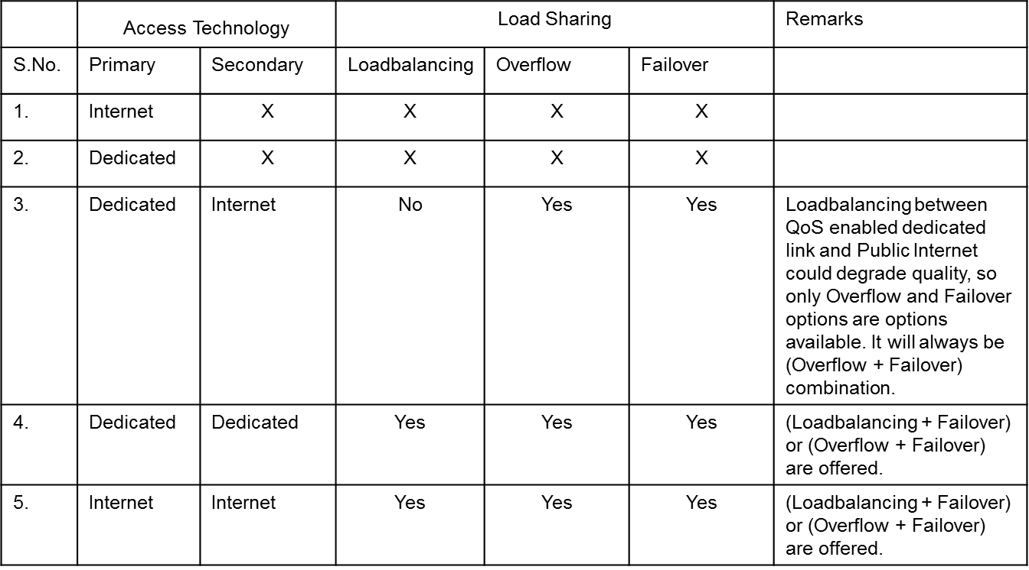

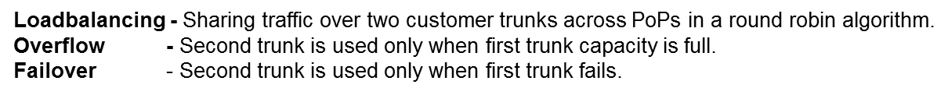

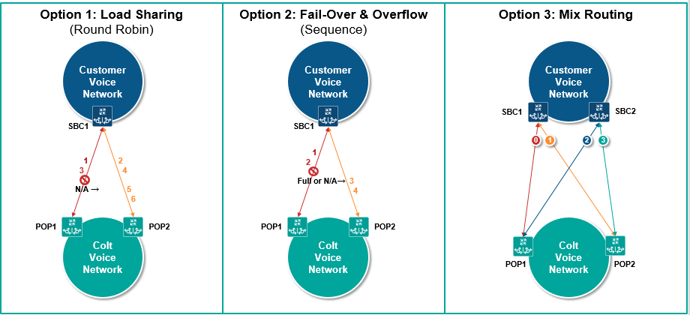

## Access Options

### Primary is Dedicated, Secondary is Internet

In this combination of connection type (primary-dedicated, secondary-internet), only (Overflow + Failover) could be offered. Load balancing between trunk over dedicated connection and public internet will provide no guaranteed QoS for every alternate call (i.e. all call over internet). So load balancing will not be part of standard service for this connection type.

**CASE 1: Customer with single site**

Two trunks will be configured for these types of connection.

* Trunk 1 will be configured between customer site 1 and IMS PoP A.
* Trunk 2 will be configured between customer site 1 and IMS PoP B.

Resiliency for the traffic flow from Customer site to IMS PoP is the responsibility of a customer. Colt will offer resiliency of trunk for calls from IMS PoP to customer site.

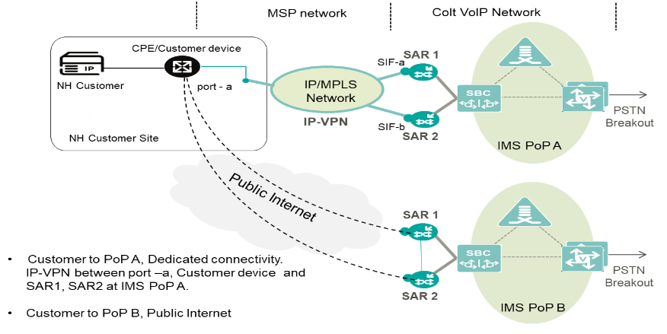

*Primary dedicated and secondary public internet; customer single site*

**CASE 2: Customer with two sites**

Two trunks will be configured for these types of connection.

* Trunk 1 will be configured between customer site 1 and IMS PoP A.
* Trunk 2 will be configured between customer site 2 and IMS PoP B.

It is the responsibility of customer to route traffic between the trunks. The transport such as dedicated connectivity or public internet will not allow a customer site to send Voice traffic to both the PoPs from each site. Site 1 will send traffic to PoP A and site 2 will send traffic to PoP B only. For all incoming calls to Colt, if customer needs overflow/failover between the PoPs then customer should do the voice routing across PoPs (A or B) at their end. But for all outgoing calls to customer from Colt, the overflow + failover functionality will be provided by Colt. In this case if trunk1 fails/overflows then trunk 2 will be used to send the call from Colt to customer.

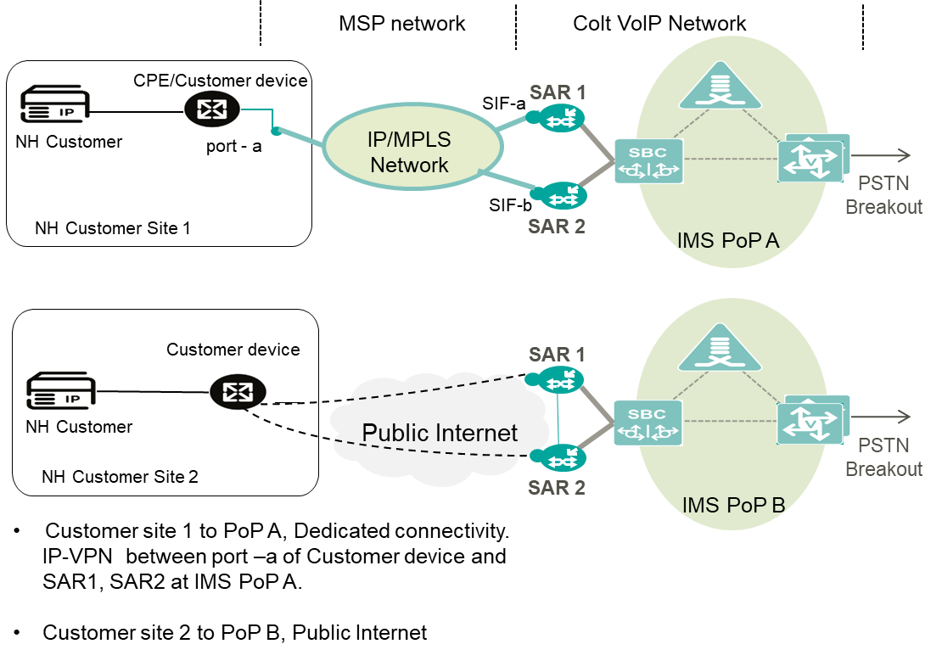

*Primary dedicated and secondary public internet; customer with two sites*

### Primary Dedicated, Secondary Dedicated

If a customer is connected to two PoPs then two separate IP VPNs will be required. The reason for choosing two IP VPNs is to avoid bandwidth choking between Pes.

Resiliency for the traffic flow from Customer site to IMS PoP is the responsibility of a customer. Colt will offer resiliency of trunk for calls from IMS PoP to customer site.

(Overflow + Failover), (Load balancing + Failover) will be offered in this combination of connection type i.e. primary-dedicated, secondary-dedicated.

**CASE 1: Customer with single site + PoP resiliency + 2 trunks**

Two trunks will be configured for these types of connection.

* Trunk 1 will be configured between customer site 1 and IMS PoP A.
* Trunk 2 will be configured between customer site 1 and IMS PoP B.

**Single/dual MSP CPE**

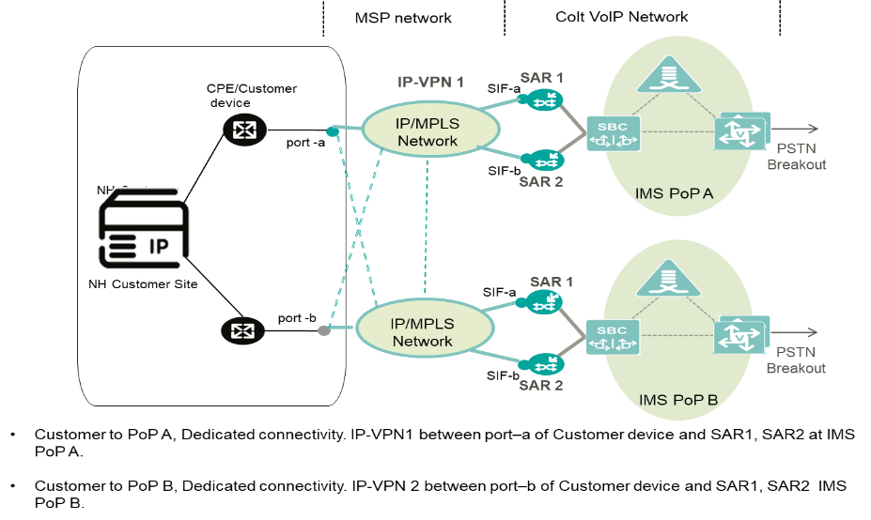

*Primary/secondary dedicated; customer single site; single/dual MSP CPE*

**CASE 2: Customer with 2 sites + PoP resiliency + 2 trunks**

Two trunks will be configured for these types of connection.

* Trunk 1 will be configured between customer site 1 and IMS PoP A.
* Trunk 2 will be configured between customer site 2 and IMS PoP B.

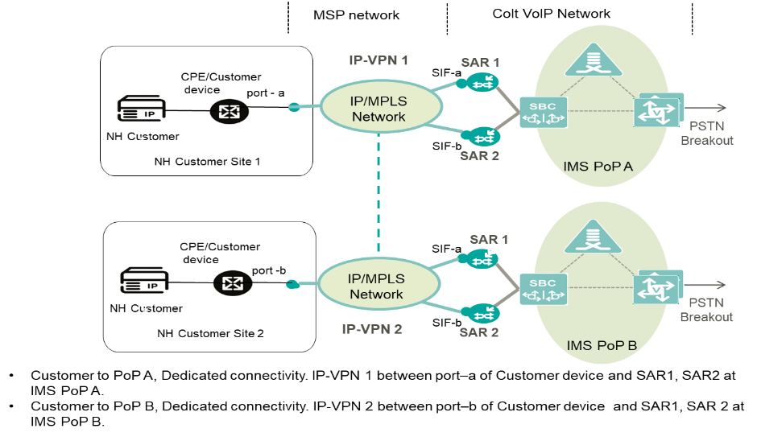

*Primary dedicated, secondary dedicated; 2 customer sites; 1 MSP CPE at each site, 2 trunks.*

**CASE 3: Customer with 2 sites + PoP resiliency + 4 trunks**

Four trunks will be configured for these types of connection.

* Trunk 1 will be configured between customer site 1 and IMS PoP A.
* Trunk 2 will be configured between customer site 1 and IMS PoP B.
* Trunk 3 will be configured between customer site 2 and IMS PoP B.
* Trunk 4 will be configured between customer site 2 and IMS PoP A.

Single MSP L2 CPE at each site

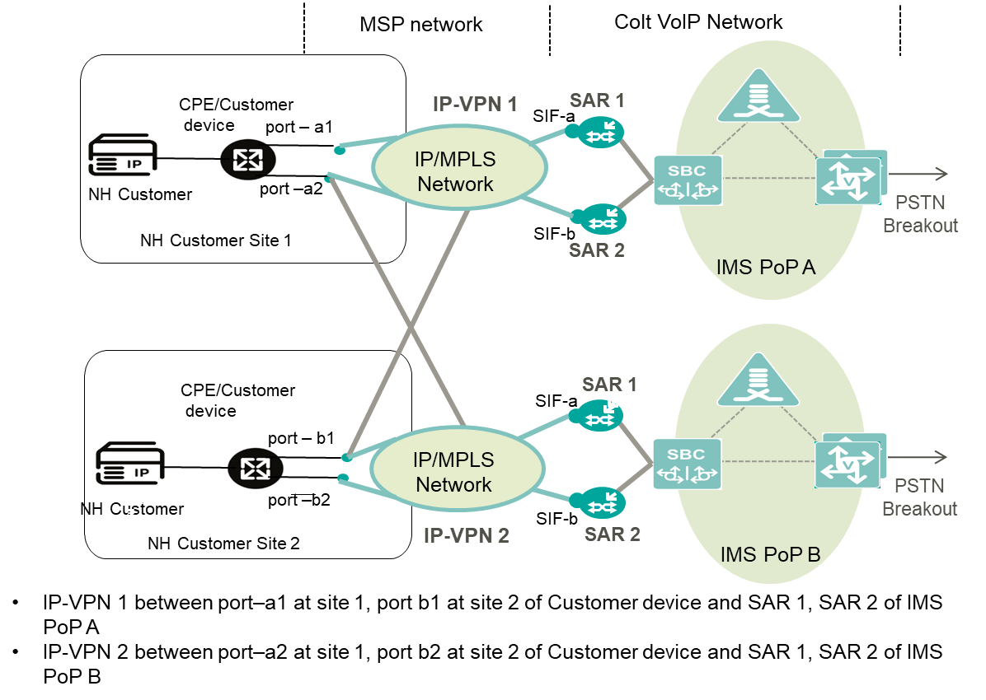

*Primary- secondary dedicated; 2 sites; 1 MSP CPE at each site; 4 trunks*

### Primary Internet, Secondary Internet

**Trunk configuration will be same for CASE1 and CASE2.**

Two trunks will be configured for these types of connection:

* Trunk 1 will be configured between customer site 1 and IMS PoP A.
* Trunk 2 will be configured between customer site 1 and IMS PoP B.

Resiliency for the traffic flow from Customer site to IMS PoP is the responsibility of a customer. Colt will offer resiliency of trunk for calls from IMS PoP to customer site.

Overflow, load balancing and Failover will be offered in this combination of connection type i.e. primary-internet, secondary-internet.

**CASE 1: Customer with single site**

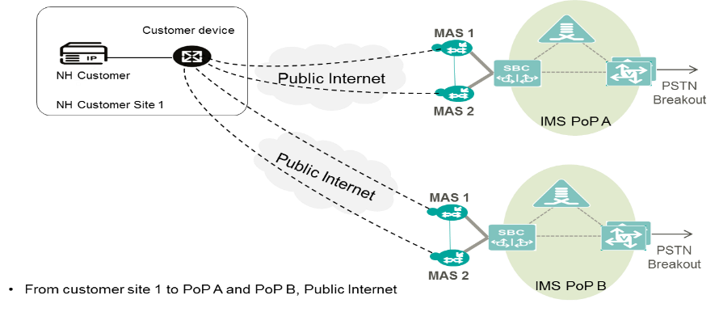

*Primary internet and secondary internet; 2 trunks; 1 site*

**CASE 2: Customer with two sites**

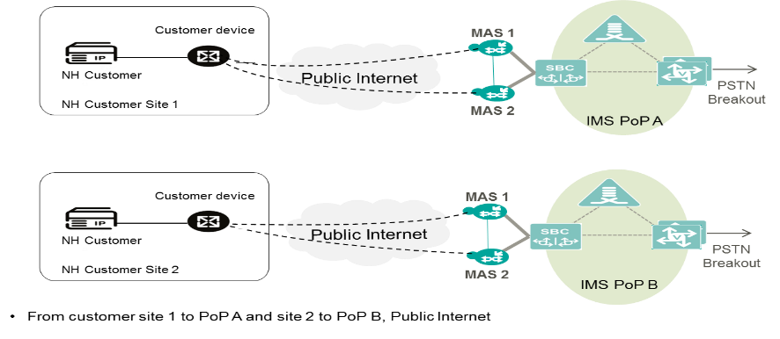

*Primary internet and secondary internet; 2 trunks; 2 sites*

## Trunk Resiliency

Trunk resiliency secures communication against any failure between the customer IP-PBX and Colt SBC. Resilient trunks can also be used for load sharing across multiple SIP peers. One primary trunk can have maximum up to **26 secondary or resilient trunks**.

Any of the trunk topologies described in the previous section can be used to provide resiliency or load sharing. For geographic redundancy, secondary trunks can be built on a separate SBC and POP.

### Call Routing

**Outgoing Call Distribution (Customer à Colt)**

For outgoing calls, resilient trunks operate in active/active configuration – calls can be sent to any trunk. The customer decides the outgoing call distribution.

**Incoming Call Distribution (Colt à Customer)**

For incoming calls, resilient trunks can operate as follows:

* **Active/Standby** - In this method a sequential route selection is used. Calls will first be attempted on the primary or active trunk. In the event of primary trunk is unreachable (no response to SIP Invite or TCP timer expiry) or the number of calls exceeds the call limit set, calls will be attempted on the next available secondary (or standby) trunk.
* **Load share** - In this method round-robin route selection is used routing call which results in 50:50 load-share across available trunks. Therefore, it is also called as load sharing. Whenever trunk exceeds call limit set or unreachable will be put off from selection till it restored to normal.

### Trunk Out of Service and Recovery Methods

Resilient trunks make use of the following failure detection and recovery mechanism.

**Failure Detection**

1st Call (Failure Detected): The Colt SBC attempts call on Trunk 1. When the SIP INVITE transaction or TCP connection timer expires the SBC attempts the call on Trunk 2. An additional PDD is incurred. The SBC blacklists the endpoint ip address belonging to Trunk 1.

Subsequent Calls: SBC attempts call on Trunk 2, no additional PDD.

The following timers are configured:

* SIP-UDP: INVITE retry timer expires – 1.5s (1 retry)
* SIP-TCP: TCP Timeout – 5 Secs

Failure detection using SIP OPTIONs ping is also possible as bespoke configuration.

**Recovery Mechanism**

Two types of recovery methods are supported a) timer based b) SIP OPTION ping.

When a trunk endpoint is blacklisted a recovery timer is used to determine when the endpoint can be removed from the black list. The recovery timer is set to 180sec (3mins)

After the recovery timer expires calls are attempted again on Trunk 1.

An alternative recovery algorithm is available which uses a SIP OPTION Ping. When an endpoint is blacklisted, the SBC sends a SIP OPTION message every 3s. As soon as the endpoint responds with 200 OK, trunk will be put back into in-service.

# Emergency Service Numbers & Short Numbers calls

Colt Wholesale SIP supports calls to Emergency Service access numbers. Call routing might require special digit translation rules before terminating the call.

Colt Wholesale SIP supports calls to short code access numbers. These numbers are significantly shorter than full telephone numbers and usually associated with special services (enquiry, social help etc.).

In all countries, the supported format is +CC [Dialled Emergency number or short code]

## List of supported numbers

Please refer to our website to view the list of Emergency Service Numbers and Short code access numbers by country: [https://www.colt.net/ngn-special-number-pricing/](https://eur01.safelinks.protection.outlook.com/?url=https%3A%2F%2Fwww.colt.net%2Fngn-special-number-pricing%2F&data=04%7C01%7CPenelope.Hickling%40colt.net%7C22c271b6e8ab4f115bc808d984e12c8d%7Cb859cf7eff8a40bbbd0fda56e6dc0eb8%7C1%7C0%7C637686930917664008%7CUnknown%7CTWFpbGZsb3d8eyJWIjoiMC4wLjAwMDAiLCJQIjoiV2luMzIiLCJBTiI6Ik1haWwiLCJXVCI6Mn0%3D%7C1000&sdata=4sydav29gjTo3%2BbZt18gGLLD%2BSX2qVdqxdV8AT0mMfU%3D&reserved=0).

*In Spain, some numbers are only available in some areas. Please find availability at ‘Province’ level. Some exceptions might apply at municipality level. This information is valid as of November 2021.*

|  |  |  |  |  |  |  |  |  |  |  |  |  |  |
| --- | --- | --- | --- | --- | --- | --- | --- | --- | --- | --- | --- | --- | --- |
| Province | 011 | 061 | 062 | 065 | 080 | 085 | 088 | 091 | 092 | 112 | 1006 | 116000 | 116111 |
| ALAVA | Y | N | Y | N | N | N | Y | Y | Y | Y | N | Y | Y |
| ALBACETE | Y | Y | Y | N | Y | Y | N | Y | Y | Y | N | Y | Y |
| ALICANTE | Y | N | Y | N | N | Y | N | Y | Y | Y | N | Y | Y |
| ALMERIA | Y | Y | Y | N | Y | N | N | Y | Y | Y | N | Y | Y |
| ASTURIAS | Y | Y | Y | N | Y | N | N | Y | Y | Y | N | Y | Y |
| AVILA | Y | Y | Y | N | Y | N | N | Y | Y | Y | N | Y | Y |
| BADAJOZ | Y | Y | Y | N | Y | Y | N | Y | Y | Y | N | Y | Y |
| BARCELONA | Y | Y | Y | N | N | Y | Y | Y | Y | Y | Y | Y | Y |
| BURGOS | Y | Y | Y | N | Y | N | N | Y | Y | Y | N | Y | Y |
| CACERES | Y | Y | Y | N | Y | N | N | Y | Y | Y | N | Y | Y |
| CADIZ | Y | Y | Y | N | N | Y | N | Y | Y | Y | N | Y | Y |
| CANTABRIA | Y | Y | Y | N | Y | N | N | Y | Y | Y | Y | Y | Y |
| CASTELLON | Y | N | Y | N | N | Y | N | Y | Y | Y | N | Y | Y |
| CEUTA | Y | Y | Y | N | Y | N | N | Y | Y | Y | N | Y | Y |
| CIUDAD REAL | Y | Y | Y | N | N | N | N | Y | Y | Y | Y | Y | Y |
| CORDOBA | Y | Y | Y | N | Y | N | N | Y | Y | Y | N | Y | Y |
| CORUÑA | Y | Y | Y | Y | Y | Y | N | Y | Y | Y | N | Y | Y |
| CUENCA | Y | Y | Y | N | N | N | N | Y | Y | Y | N | Y | Y |
| GERONA | Y | Y | Y | N | N | Y | Y | Y | Y | Y | Y | Y | Y |
| GRANADA | Y | Y | Y | N | Y | N | N | Y | Y | Y | N | Y | Y |
| GUADALAJARA | Y | Y | Y | N | Y | N | N | Y | Y | Y | N | Y | Y |
| GUIPUZCOA | Y | N | Y | N | Y | N | Y | Y | Y | Y | N | Y | Y |
| HUELVA | Y | Y | Y | N | Y | N | N | Y | Y | Y | N | Y | Y |
| HUESCA | Y | Y | Y | N | N | N | N | Y | Y | Y | N | Y | Y |
| ILLES BALEARS | Y | Y | Y | N | Y | Y | N | Y | Y | Y | N | Y | Y |
| JAEN | Y | Y | Y | N | Y | N | N | Y | Y | Y | N | Y | Y |
| LA RIOJA | Y | Y | Y | N | N | Y | N | Y | Y | Y | N | Y | Y |
| LAS PALMAS | Y | Y | Y | N | Y | N | N | Y | Y | Y | N | Y | Y |
| LEON | Y | Y | Y | N | Y | N | N | Y | Y | Y | N | Y | Y |
| LERIDA | Y | Y | Y | N | N | Y | Y | Y | Y | Y | Y | Y | Y |
| LUGO | Y | Y | Y | Y | Y | Y | N | Y | Y | Y | Y | Y | Y |
| MADRID | Y | Y | Y | N | Y | Y | N | Y | Y | Y | N | Y | Y |
| MALAGA | Y | Y | Y | N | Y | Y | N | Y | Y | Y | N | Y | Y |
| MELILLA | Y | Y | Y | N | Y | N | N | Y | Y | Y | N | Y | Y |
| MURCIA | Y | Y | Y | N | Y | N | N | Y | Y | Y | N | Y | Y |
| NAVARRA | Y | Y | Y | N | N | N | Y | Y | Y | Y | N | Y | Y |
| OURENSE | Y | Y | Y | Y | Y | Y | N | Y | Y | Y | N | Y | Y |
| PALENCIA | Y | Y | Y | N | N | N | N | Y | N | Y | N | Y | Y |
| PONTEVEDRA | Y | Y | Y | Y | Y | Y | N | Y | Y | Y | N | Y | Y |
| SALAMANCA | Y | Y | Y | N | Y | N | N | Y | Y | Y | N | Y | Y |
| SANTA CRUZ DE TENERIFE | Y | Y | Y | N | Y | N | N | Y | Y | Y | N | Y | Y |
| SEGOVIA | Y | Y | Y | N | N | N | N | Y | N | Y | N | Y | Y |
| SEVILLA | Y | Y | Y | N | Y | Y | N | Y | Y | Y | N | Y | Y |
| SORIA | Y | Y | Y | N | N | Y | N | Y | N | Y | N | Y | Y |
| TARRAGONA | Y | Y | Y | N | N | Y | Y | Y | Y | Y | Y | Y | Y |
| TERUEL | Y | Y | Y | N | N | N | N | Y | Y | Y | N | Y | Y |
| TOLEDO | Y | Y | Y | N | Y | Y | N | Y | Y | Y | N | Y | Y |
| VALENCIA | Y | N | Y | N | Y | Y | N | Y | Y | Y | N | Y | Y |
| VALLADOLID | Y | Y | Y | N | Y | Y | N | Y | Y | Y | N | Y | Y |
| VIZCAYA | Y | N | Y | N | Y | N | Y | Y | Y | Y | N | Y | Y |
| ZAMORA | Y | Y | Y | N | N | N | N | Y | Y | Y | N | Y | Y |
| ZARAGOZA | Y | Y | Y | N | N | N | N | Y | Y | Y | N | Y | Y |
| **Coverage** | **National** | **Partial** | **National** | **Partial** | **Partial** | **Partial** | **Partial** | **National** | **Partial** | **National** | **Partial** | **National** | **National** |

|  |  |
| --- | --- |
| *http://downloadicons.net/sites/default/files/warning-sign-icon-63117.png* | *Emergency calls service is supported only for CLIs hosted on Wholesale SIP. All forwarded Emergency calls are blocked.*  *Short numbers call service is supported only for CLIs hosted on Wholesale SIP.*  *Your responsibility remains to optimize the dialled digits by your end-customers, into international format.* |

## Emergency Call Routing (ECR)

Colt supports emergency calls in all countries. The processing on the network depends on national regulation. In each country, legal and/or regulatory requirements stipulate the manner in which a telephone call from a given end-customer to an emergency services number should be routed.

Emergency call routing based on ELIN is not applicable / supported in our country footprint.

Once Colt collects emergency calls from you, Colt has to deliver these calls in a specific number format, respecting the legal & regulatory requirements.

Emergency call processing is split into 3 different groups:

* Centralized, meaning all calls will be routed to the same Emergency service.
* LAC based[[2]](#footnote-3), meaning calls will be routed to the Emergency service based on the LAC/first digits of telephone number.
* Location based, meaning calls will be routed to the Emergency service based on the end-customer’s address.

Please find below overview of the availability per country:

|  |  |
| --- | --- |
| Country | Routing |
| **Austria** | LAC based (nomadic/personal numbers 4) |
| **Belgium** | Location based |
| **Czech Republic** | Location based |
| **Denmark** | Location based |
| **Finland** | Location based |
| **France** | Location based |
| **Germany** | Location based |
| **Luxembourg** | Centralized |
| **Ireland** | Centralized |
| **Italy** | LAC based |
| **Netherlands** | LAC based |
| **Norway** | Location based |
| **Poland** | Location based |
| **Portugal** | LAC based |
| **Romania** | Location based |
| **Slovakia** | Location based |
| **Spain** | Location based |
| **Sweden** | Location based |
| **Switzerland** | Location based |
| **United Kingdom** | Centralized |

It remains the customer’s responsibility regarding calls to Emergency Services to:

* Keep accurate and up to date end-customer information.
* Optimize the digits dialed from your end-customer into international format.

**Germany, Switzerland & Portugal**

We insert the end-customer’s address in the SIP header of the emergency call and the PSAPs can then retrieve the address from the SIP header. The address cannot be sent dynamically by the Wholesale SIP customer but will be inserted by Colt based on the address captured for the CLI in the original number activation or port-in order and held in our database. This is also being implemented for Portugal in Q125.

# VoIP Performance Reporting

Colt offers you its VoIP Online Performance Reporting tool to track your VoIP and data KPIs.

|  |  |
| --- | --- |
| IP Statistics  Colt provided connectivity only (IP VPN) | VoIP Statistics |
| * Network performance. * Jitter network performance:   + Reachability   + Packet loss * MOS (calculated on IP statistics between customer CPE and Colt VoIP backbone). | * Answer seizure ratio, network efficiency ratio. * Answered calls, unanswered calls, and failed calls. * Mean conversation time, mean holding time per seizure, total conversation time. * Data measured per trunk group or destination |

VoIP Online Performance Reporting tool is an optional and chargeable option. For more information, please contact your Account Executive.

# **Glossary**

|  |  |
| --- | --- |
| Term | Description |
| AT | Austria country |
| B2B | Business to Business |
| BE | Belgium country |
| CC | Country Code (SIP trunking related) |
| CC | Country Code (SIP trunking related) |
| CdPN | Called Party Number or ‘B’ Number (SIP trunking related) |
| CDR | Call Detail Record |
| CgPN | Calling Party Number or ‘A’ Number (SIP trunking related) |
| CH | Switzerland country |
| CLI | Calling Line Identification (SIP trunking related) |
| CLIP | Calling Line Identification Presentation (or Caller ID) (SIP trunking related) |
| CLIR | Calling Line Identification Restriction (SIP trunking related) |
| Cocom | The **Co**lt **Com**munication System |
| Colt Online | Colt Web-based portal to manage your services. |
| CPS | Call per Second (SIP trunking related) |
| DE | Germany country |
| DK | Denmark country |
| DN | Default Number (SIP trunking related) |
| EOF | Electronic Order Form |
| ES | Spain country |
| FCC | Federal Communications Commission (US Regulatory Authority) |
| FQDN | Fully Qualified Domain name (SIP trunking related) |
| FR | France country |
| FTP | File Transfer Protocol |
| GB | Great Britain (United Kingdom / UK) country |
| GN | Generic Number (ISUP) (SIP trunking related) |
| GNP | Geographic Number Portability |
| HTML | Hyper Text Markup Language |
| HTTP | Hypertext Transfer Protocol |
| HTTPS | Hypertext Transfer Protocol Secure |
| ICR | Inbound Call Re-Routing (Product Feature) (SIP trunking related) |
| IE | Ireland country |
| IT | Italy country |
| LAC | Local Area Code |
| LOA | Letter of Authorization |
| MGW | Media Gateway (SIP trunking related) |
| NAT | Network Address Translation (SIP trunking related) |
| NL | The Netherlands |
| NOA | Nature of Address (SIP trunking related) |
| NP | Network Provided (Screening) (SIP trunking related) |
| NSN | National Significant Number (SIP trunking related) |
| NSN | National Significant Number |
| OOH | Out of Office |
| PAI | P-Asserted-Identity header field used in SIP signalling (SIP trunking related) |
| PAI | P-Asserted-Identity (SIP) (SIP trunking related) |
| PANI | P-Access-Network-Info SIP Header |
| PDD | Post Dial Delay (SIP trunking related) |
| PI | Presentation Indicator (ISUP) (SIP trunking related) |
| PN | Presentation Number (SIP trunking related) |
| PNR | Partial Number Replacement (Product Feature) (SIP trunking related) |
| PoP | Point of Presentation (SIP trunking related) |
| PPI | P-Preferred-Identity (SIP) (SIP trunking related) |
| PT | Portugal country |
| PTT | Public Telegraph Telephony [operator]: Any fixed-line network operator but typically the major incumbent operator within the country, |
| RDN | Redirecting Number (SIP trunking related) |
| RPI | Remote Party Id (SIP) (SIP trunking related) |
| RMD | Robocall Mitigation Database (owned by US FCC) |
| SBC | Session Border Controller (SIP trunking related) |
| SDES | Secure Descriptions (SIP trunking related) |
| SE | Sweden |
| SI | Screening Indicator (ISUP) (SIP trunking related) |
| SIP | Session Initiation Protocol (SIP trunking related) |
| SMTP | Simple Mail Transfer Protocol |
| SRTP | Secure Real Time Protocol (SIP trunking related) |
| Surrendering (Donor) Carrier | The carrier being requested to port the numbers to Colt. |
| TLS | Transport Layer Security (SIP trunking related) |
| TN | Telephone Number |
| Trunk | Logical entity used for VoIP signalling and media, defined between a unique pair of IP addresses on the Colt SBC and Customer VoIP platform |
| Trunkgroup | A group of trunks that share the same DDI number ranges and typically used for resiliency |
| URL | Uniform Resource Locator |
| VPN | Virtual Private Network |
| WWW | World Wide Web |
| XML | eXtensible Markup Language |

1. [↑](#footnote-ref-2)
2. Call originated from Location Independent Number is routed to a default central location

   4 Nomadic (0720) and personal numbers (050,0517,057,059): Colt set default LAC 01 (Vienna). Wholesale SIP customer may send emergency calls to Colt in the format +43 <LAC>-<emergency number>, with the LAC corresponding to the location of the caller. [↑](#footnote-ref-3)