Porting Guidance for Customer
On how to fill
Ireland Porting Letter of Authority (LOA)
/
Customer Authorisation Form (CAF)
/
Customer Instruction Form (CIF)

Document Version 1.0
Release Date 22/04/2019
Author Ashish Singh Chouhan

Disclosure / Confidentiality
Highly Confidential, not for distribution ☐
Distribution within Architecture & Design ☐
Distribution within Colt ☐
Distribution permitted external to Colt ☒

Contents
1. Document Information 3
1.1. Version History 3
1.2. Document Approvals 3
1.3. Executive Summary 3
1.4. Intended Audience 3
1.5. Porting Guidance for Customer 4

Document Information
File Location:
http://connect.internal.colt.net/porting-information/

Version History
Version | Issue Date | Author | Reason for Change
1.0 | 22/04/2019 | Ashish Singh Chouhan | Initial Draft

Document Approvals
Department | Name | Issue | Date
COO - Voice Service Delivery | Chhayadeep Verma | 1.0 | 22/04/2019

Executive Summary
This document describes the guidance for customer to fill standard porting Letter of authority to request porting on their existing Colt voice service.

Intended Audience
Voice delivery, Porting teams, Order Management and Colt customer.
Process Description-

We have a copy of standard porting LOA for porting geographic and non-geographic numbers as following for a walkthrough with details-

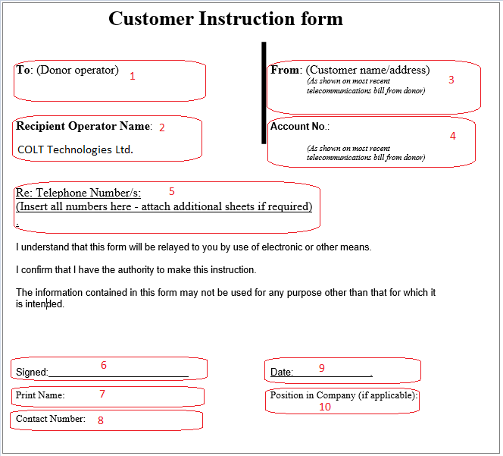

Note: Please keep a copy of latest invoice handy while filling out the LOA with following inputs required.

- To (Donor Operator) – Put the name of the customer’s current communication provider as per invoice.
- Recipient Operator Name – Keep this ‘unchanged’. This has COLT details as gaining communication provider.
- From – Put the customer name and registered address as per mentioned in latest invoice.
- Account No. - This is the account number of customer registered with losing communication provider.
- Telephone Number/s – This shall contain the details of numbers customer wishes to port.
- Signed – Customer must duly sign the LOA at this field.
- Print Name – Keep the name of authorised person signing the LOA at customer end.
- Contact Number – Put the contact details of the requestor for reference.
- Date – Enter the date on which customer signs the LOA. In general, customer LOA is valid for 90 days from the signed date
- Position in Company – Mention the job title of the contact person at customer site being authorised to request number portability on Company’s behalf.

