Porting Guidance for Customer
On how to fill
Netherlands Porting Letter of Authority (LOA)

Document Version 1.0
Release Date 22/04/2019
Author Ashish Singh Chouhan

Disclosure / Confidentiality
Highly Confidential, not for distribution ☐
Distribution within Architecture & Design ☐
Distribution within Colt ☐
Distribution permitted external to Colt ☒

Contents
1. Document Information 3
1.1. Version History 3
1.2. Document Approvals 3
1.3. Executive Summary 3
1.4. Intended Audience 3
1.5. Porting Guidance for Customer 4
1.6. Porting LOA’s………………………………………………………………………………………11

Document Information
File Location:
http://connect.internal.colt.net/porting-information/

Version History
Version | Issue Date | Author | Reason for Change
1.0 | 22/04/2019 | Ashish Singh Chouhan | Initial Draft
1.1 | 4/03/2024 | Vincent Charite | New LOA’s (Early Termination and Standard)

Document Approvals
Department | Name | Issue | Date
COO - Voice Service Delivery | Chhayadeep Verma | 1.0 | 22/04/2019

Executive Summary
This document describes the guidance for customer to fill porting Letter of authority to request porting on their existing Colt voice service.

Intended Audience
Voice delivery, Porting teams, Order Management and Colt customer.
1.5. Porting Guidance for Customer

1) Standard LOA
Here an example of an standard porting LOA for porting geographic and non-geographic numbers as following for a walkthrough with details
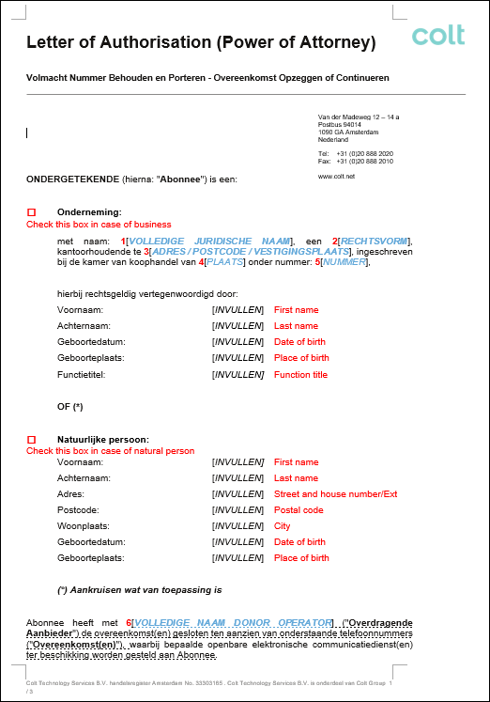

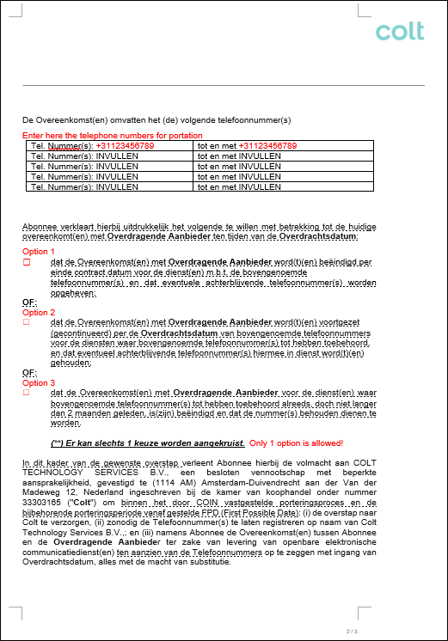

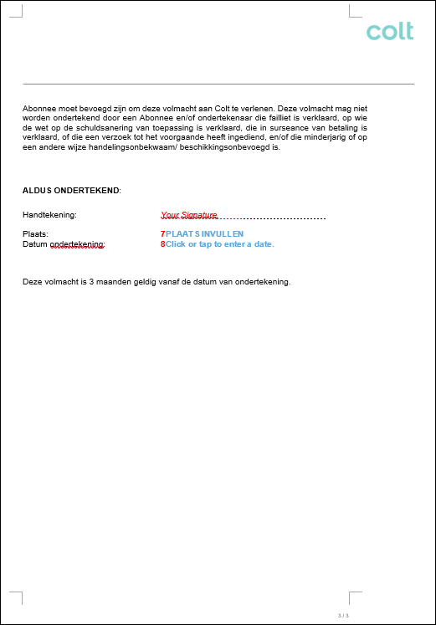

Note: Please keep a copy of latest invoice handy while filling out the LOA with following inputs required.

Standard LOA explanations:
Please select if you are a business or natural person and enter the required details. The red highlighted numbering explains here what is meant or it is detailed in red in the picture itself:

- VOLLEDIGE JURIDISCHE NAAM – Enter the full legal name of the company.
- RECHTSVORM – Enter the legal form of the company (for ex: BV – NV – VOF etc)
- ADRES / POSTCODE / VESTIGINGSPLAATS – Enter the main office full address details: street/building number/postal code and city of residency!
- PLAATS – Enter Chamber of Commerce location.
- NUMMER – Enter Chamber of Commerce registration number.
- VOLLEDIGE NAAM DONOR OPERATOR – Enter the full name of the donor operator involved.
- PLAATS INVULLEN – Enter the city of signature.
- Datum ondertekening - Enter the date on which customer signs the LOA. In general, customer LOA is valid for 90 days from the signed date

Option 1 indicates Default Port:
The FPD will be provided by losing operator based on existing contract term customer has. Usually this date is set as per the end of a notice period or contract term!

Option 2 indicates Continuation port:
The FPD is to be provided as a same day port request where the existing contract with the provider is not terminated but continued with all responsibilities containing this contract at releasing carrier. This option can be when a partial port is requested/needed!

Option 3 indicates Port after cease of services/numbers (Default Port):
If customer mistakenly have ceased their numbers at current operator but wants to port their numbers anyway although within the first 2 months after the cease has been completed with current operator. Numbers are to be retained at the new operator so port date should be received as same day port!

2) Early Termination LOA
Here an example of an Early Termination porting LOA for porting geographic and non-geographic numbers as following for a walkthrough with details
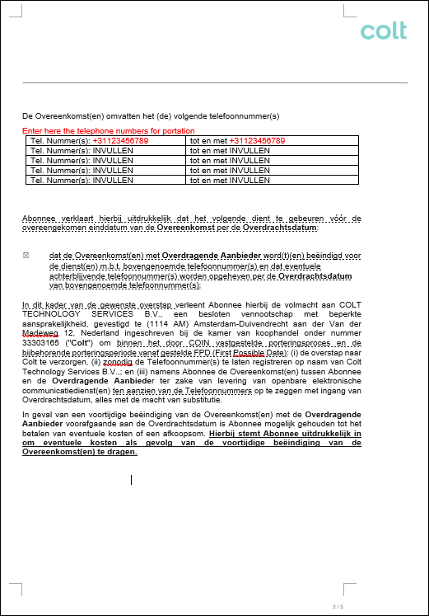

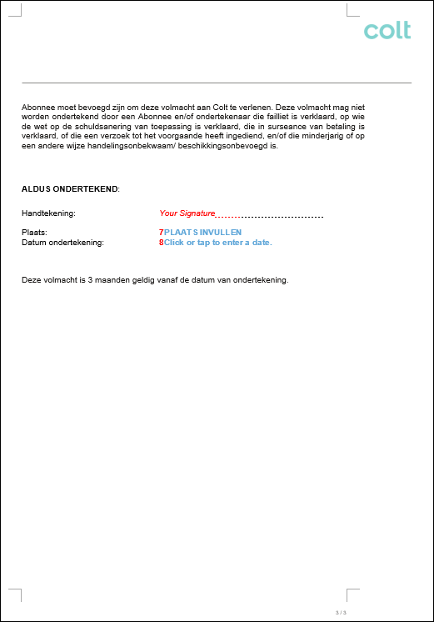

Note: Please keep a copy of latest invoice handy while filling out the LOA with following inputs required.

Early Termination LOA explanations:
Please select if you are a business or natural person and enter the required details. The red highlighted numbering explains here what is meant or it is detailed in red in the picture itself:

- VOLLEDIGE JURIDISCHE NAAM – Enter the full legal name of the company.
- RECHTSVORM – Enter the legal form of the company (for ex: BV – NV – VOF etc)
- ADRES / POSTCODE / VESTIGINGSPLAATS – Enter the main office full address details: street/building number/postal code and city of residency!
- PLAATS – Enter Chamber of Commerce location.
- NUMMER – Enter Chamber of Commerce registration number.
- VOLLEDIGE NAAM DONOR OPERATOR – Enter the full name of the donor operator involved.
- PLAATS INVULLEN – Enter the city of signature.
- Datum ondertekening - Enter the date on which customer signs the LOA. In general, customer LOA is valid for 90 days from the signed date

The only option on this form which is mandatory indicates Early Termination port:
If customer wants to port their numbers before end of contract term and with this want to cease their contract for these numbers this LOA is required. This is not to be used as quick port option as it is absolutely not the case as it has legal contract end obligations and consequences for the customer and has a minimum acceptance lead time. This is to notify releasing operator to end the contract associated to affected numbers before end of contract end date and customer accepts terms and conditions.

1.6. Porting LOA’s

Dutch forms:

English forms:

