|  |
| --- |
| Colt Wholesale SIP (Number Hosting) 11th Jan 2025 Release Notes |

# Introduction

This document describes the Colt Wholesale SIP (Number Hosting) 11th Jan 2025 release.

The release will focus on

1. numberEnquiry/numberCollection API response
2. NOD and B2B API improvements
3. New REST APIs on APIGEE and developer portal

**These changes might imply development at your end, so please read this document carefully.**

The changes in this release require your support during our test period. The Customer UAT is planned from 25th Nov 2024 to 29th Nov 2024. Please get in touch with [NumberHostingUATSupportTeam@COLT.NET](mailto:NumberHostingUATSupportTeam@COLT.NET) if you would like to participate in the UAT.

# Document change control

|  |  |
| --- | --- |
| **Version** | **Change description** |
| V1 | 11th Jan 2025 Release note |
| V2 | Updates made 20th Nov 2024 to these release notes with more details of the following:   * ***numberEnquiry / numberCollection API response*** section updated to reflect REST and SOAP/HTTPs sample responses * More details added for new REST APIGEE APIs along with OAS specifications * Added updated OAS specifications for existing number management API in ‘Appendix B: API specifications’ * Added NOD screenshots in ‘Appendix C: NOD UI changes’ |

# numberEnquiry / numberCollection API response

Consistent and user-friendly responses will be sent in the numberEnquiry / numberCollection REST API response.

**Code breaking change:** Yes

**Impacted APIs:**

* **SOAP/HTTPS**: numberEnquiry (new errorType, errorCode, errorDescription and businessErrorDescription)
* **REST**: GET/numberCollection (new errorCode, message)

Please refer to the table below for the existing error code/response and new error type, code and description.

|  |  |  |  |  |
| --- | --- | --- | --- | --- |
| Country | Scenarios | Current response | New response (REST API) | New Response (SOAP/HTTPS) |
| DE | No number found for free number search | errorType: **supportServiceAvailability**  errorCode: **FNAA00106**  errorDescription: No matching range found for the given criteria. Please request for free numbers via ‘Number on Demand’ portal or by contacting ResellerSupport.Voice@colt.net  businessErrorDescription: No matching range found for the given criteria. Please request for free numbers via ‘Number on Demand’ portal or by contacting ResellerSupport.Voice@colt.net | {  "code": "781",   "reason": "Record not found",   "message": "No matching range found for the given criteria. Please request for free numbers via ‘Number on Demand’ portal or by contacting ResellerSupport.Voice@colt.net",   "status": "400-72"  } | <nhm:status xmlns:nhm="http://www.colt.net/xml/ns/cbe/nhm/v1.0">ERROR</nhm:status>  <nhm:errorMessage xmlns:nhm="http://www.colt.net/xml/ns/cbe/nhm/v1.0">  <nhm:errorType>failure</nhm:errorType>  <nhm:errorCode>781</nhm:errorCode>  <nhm:errorDescription>Record not found</nhm:errorDescription>  <nhm:businessErrorDescription>No matching range found for the given criteria. Please request for free numbers via ‘Number on Demand’ portal or by contacting ResellerSupport.Voice@colt.net</nhm:businessErrorDescription>  </nhm:errorMessage> |
| DE | Search of number which doesn’t belong to the service profile present in the request  Search of a free number using search by CLI / customerReference | errorType: **supportServiceAvailability**  errorCode: **FNAA00161**  errorDescription: This search finds more than 100 entries. Please refine the number further.  businessErrorDescription: This search finds more than 100 entries. Please refine the number further. | {      "code": "782",      "reason": "Record not found",      "message": "No matching range found for the given criteria.",      "status": "400-73"  } | <nhm:status xmlns:nhm="http://www.colt.net/xml/ns/cbe/nhm/v1.0">ERROR</nhm:status>  <nhm:errorMessage xmlns:nhm="http://www.colt.net/xml/ns/cbe/nhm/v1.0"> <nhm:errorType>failure</nhm:errorType>  <nhm:errorCode>782</nhm:errorCode>  <nhm:errorDescription>Record not found</nhm:errorDescription>  <nhm:businessErrorDescription>No matching range found for the given criteria.</nhm:businessErrorDescription>  </nhm:errorMessage> |
| All countries except DE | No number found for free number search | errorType: **success**  errorCode: **0**  errorDescription: No matching range found for the given criteria. Please request for free numbers via ‘Number on Demand’ portal or by contacting ResellerSupport.Voice@colt.net | {      "code": "781",      "reason": "Record not found",      "message": "No matching range found for the given criteria. Please request for free numbers via ‘Number on Demand’ portal or by contacting ResellerSupport.Voice@colt.net",      "status": "400-72"  } | <nhm:status xmlns:nhm="http://www.colt.net/xml/ns/cbe/nhm/v1.0">ERROR</nhm:status>  <nhm:errorMessage xmlns:nhm="http://www.colt.net/xml/ns/cbe/nhm/v1.0">  <nhm:errorType>failure</nhm:errorType>  <nhm:errorCode>781</nhm:errorCode>  <nhm:errorDescription>Record not found</nhm:errorDescription>  <nhm:businessErrorDescription>No matching range found for the given criteria. Please request for free numbers via ‘Number on Demand’ portal or by contacting ResellerSupport.Voice@colt.net</nhm:businessErrorDescription>  </nhm:errorMessage> |
| All countries except DE | Search of number which doesn’t belong to the service profile present in the request  search of a free number using search by CLI or customer reference or orderID/transactionID | errorType: **success**  errorCode: **0**  errorDescription: No matching range found for the given criteria. Please request for free numbers via ‘Number on Demand’ portal or by contacting ResellerSupport.Voice@colt.net | {      "code": "782",      "reason": "Record not found",      "message": "No matching range found for the given criteria.",      "status": "400-73"  } | <nhm:status xmlns:nhm="http://www.colt.net/xml/ns/cbe/nhm/v1.0">ERROR</nhm:status>  <nhm:errorMessage xmlns:nhm="http://www.colt.net/xml/ns/cbe/nhm/v1.0"> <nhm:errorType>failure</nhm:errorType>  <nhm:errorCode>782</nhm:errorCode>  <nhm:errorDescription>Record not found</nhm:errorDescription>  <nhm:businessErrorDescription>No matching range found for the given criteria.</nhm:businessErrorDescription>  </nhm:errorMessage> |

# Numbers on Demand (NOD) and B2B API improvements

Below are improvements targeted for release on 11th Jan 2025. Updated XSDs and API OAS specifications can be found in the Appendix A: XSD and Appendix B: API specifications.

***Please note***: Screenshots showing the NOD portal changes are in section ‘Appendix C: NOD UI changes’.

| Sr no | Functionality | Interface | Improvement Description | Country Scope | Code Breaking change for customer (Yes/No) |
| --- | --- | --- | --- | --- | --- |
| 1 | Numbers on Demand UI URL | NOD | The Numbers on Demand URL will be updated.  **Current**: https://my.colt.net/numberondemand **New**: https://my.colt.net/numbersondemand | All | No |
| 2 | Welcome page  My Orders  My Telephone Numbers | NOD | 1. Change in alignment of Quick links on the welcome page 2. Colours of place cards present in My Orders and My Telephone Numbers pages will be in sync with the grid status colour. | All | No |
| 3 | Request Numbers – Reservation & Activation | NOD | Change in error message and alignment of ‘Request Number’ button when the exact quantity is not returned or no free numbers are returned in the response.  Quick links to Reservation, Activation, My Telephone Numbers and My Orders pages will be displayed after you click on the ‘Request Numbers’ button. | All | No |
| 4 | Bulk Requests | NOD | Copy address feature for Bulk requests will be available for Italy, like in other countries. | IT | No |
| 5 | * Free number search * Number reservation * Number activation | NOD  APIs | Today when you search for free numbers in Poland the block sizes are: 1, 10 and 100.  As per the Polish rules in the numbering plan a block size of 100 only will be supported for free number search, reservation & activation. Partial address update can then used – see below. | PL | Yes |
| 6 | Partial Address Update | NOD  APIs | Partial address update will be allowed for blocks of 1 and 10 in both NOD and B2B API for Colt activated numbers.  A range of 10 must have the Start Range and End Range format of 0-9. A user will get an error if the number range is not entered in this format: | PL | No |
| 7 | Partial Address Update | NOD  APIs | Partial address updates on Port-In Activated numbers will not be supported for Zone B countries (LU, CZ, FI, SK, PL, RO, PL) | Zone B countries | No |

# We’re ready with our new Wholesale SIP REST APIs and Developer portal !

We plan to launch our new REST APIs on our APIGEE platform in January 2025 along with our API developer portal.

We will enable these industry standard authentication and authorisation mechanisms:-

* An Authentication API will be available. **OAuth 2.0** access token with client_credential grant type used to authenticate API calls by a registered app. The access token has a limited validity period and the expiry time is returned in the response.

Please refer to the [**OAS specification**](https://344164.fs1.hubspotusercontent-na1.net/hubfs/344164/Wholesale%20SIP%20January%202025%20Release/authorization_v1.0.0_27Aug2024.yaml) for details.

* **JWT authentication**: at the time of App registration you will find 3 options: URI, JWKS or certificate. Select any one option and then choose API bundles.

Below is the list of Wholesale SIP (Number Hosting) APIs in our January 2025 release:

|  |  |  |
| --- | --- | --- |
| Release 1 - Jan 2025  New REST APIs & developer portal | | |
| **Method: POST** | | **Method: GET** |
| **reservation/order**  🡪 Reserve a number/range | **updateCustomer/order**   * Add or update end customer details/address * Add or update directory services details | **freeNumberCount**  🡪 Get free number count available for the requested numberPrefix |
| **activation/order**  🡪 Activate a number/range | **bulkOrder**  🡪 Activation, address update and PortIn | **Order/{orderId}**  🡪 Get orderDetails for the requested orderID |
| **return/order**  🡪 Cancel reservation or Deactivate activated/port-in activated number/range | **reactivation/order**  🡪 Reactivate quarantined or port-in quarantined number/range | **freeNumber**  🡪 Get free number search using prefix (All) and CLI (for FR only) |
| **portIn/order**  🡪 portIn a number/ranges to Colt | **lockFreeNumbers**  🡪 Lock free numbers using numberPrefix for 10 mins and receive lockID to perform reservation/activation | **number**   * Number search with status, CLI, orderID or cust reference. * Response will also show number Details (end customer status, details, address,etc for activated and portin activated numbers) |
| **portUpdate/order**   * modify/ send notes/ schedule port(NL)/ cancel/ change the date of existing portIn order * Accept/reject a port out request | **freeNumberBackfill/order**   * Request for free numbers for required numberPrefix * Auto reservation by Colt post the availability of numbers without any intervention from customer | **order**  🡪 Get list of orders |
| **checkPortability**   * Check if a number/range can be ported-In or not * Internal Colt validations only | **cancelFreeNumberBackfill/order**  🡪 Cancel free number backfill order | **CLIOrderHistory**  🡪 Get the order history of the number or range |

*Release 2 - Mar 2025: Address Management API*

Please refer to the [OAS specification](https://344164.fs1.hubspotusercontent-na1.net/hubfs/344164/Wholesale%20SIP%20January%202025%20Release/numberManagement_v1.0.0_20Nov2024_R17.yaml) for details.

**Introduction of API Developer Portal**

The API developer portal is a self-registration portal (a user will need to be a Colt Online user). The portal will contain detailed information about the Wholesale SIP/Number Hosting APIs, including API endpoints, request and response formats, and usage guidelines. These can be found alongside the NGN (e.g. Freephone) APIs.

It's a central hub where developers can find all the information they need to understand, develop, and integrate Wholesale SIP APIs smoothly.  App registration for APIs will happen from this portal itself.

**How to get sandbox support**

The sandbox environment will be available from 27th Jan 2025. Support for sandbox testing will be provided by the API Support team and is a chargeable service. Please contact your account manager for further information.

# Appendix A: XSD

Please click [link 1](https://344164.fs1.hubspotusercontent-na1.net/hubfs/344164/Wholesale%20SIP%20January%202025%20Release/nhm_cbe_v3.24.xsd) and [link 2](https://344164.fs1.hubspotusercontent-na1.net/hubfs/344164/Wholesale%20SIP%20January%202025%20Release/NumberHostingServices_v3.24.xsd) for updated XSDs

# Appendix B: API specifications

## OAS Specification for number management APIs

Please click [here](https://344164.fs1.hubspotusercontent-na1.net/hubfs/344164/Wholesale%20SIP%20January%202025%20Release/numberManagement_v2.0.12_21Oct2024.yaml) for the OAS Specification for Number Management APIs.

# Appendix C: NOD UI changes

## Request Numbers – Reservation & Activation

There is a change in the error message and alignment of the ‘Request Number’ button when the exact quantity is not returned or “no free numbers” is returned in the response.

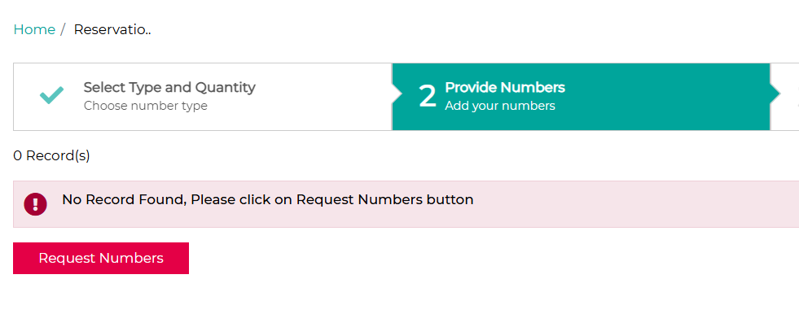

Quick links to go to Reservation, Activation, My Telephone Numbers and My Orders pages will be displayed after you click on the ‘Request Numbers’ button.

## Welcome page, My Orders, My Telephone Numbers

There is a change to the alignment of Quick links on the welcome page

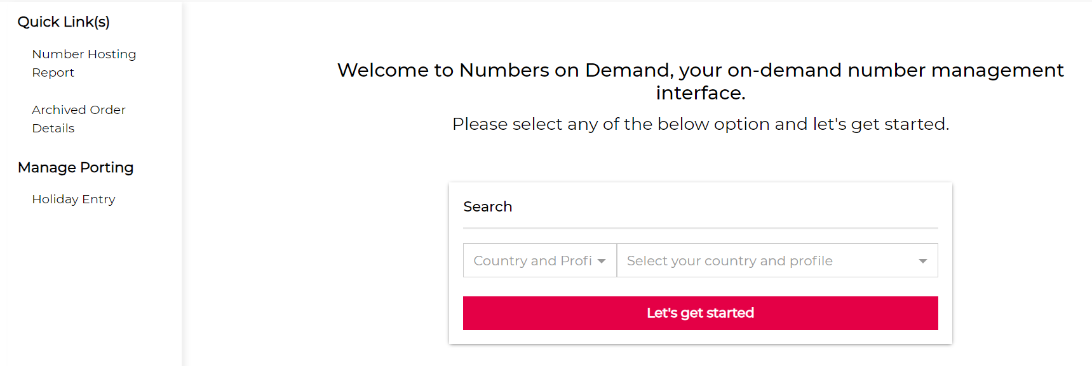

The colours of the place cards visible in My Orders and My Telephone Numbers pages will be in sync with the grid status colour: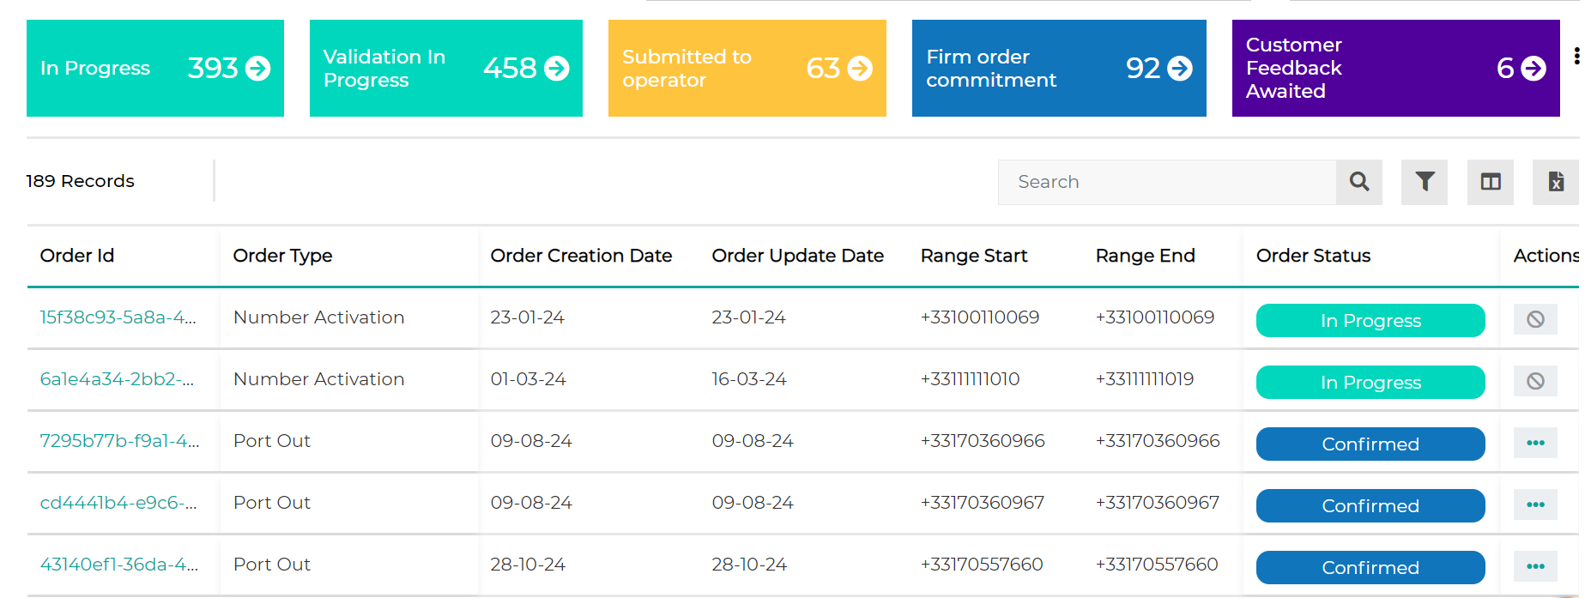

## Bulk requests

The copy address feature for bulk requests will be available for Italy like in other countries.

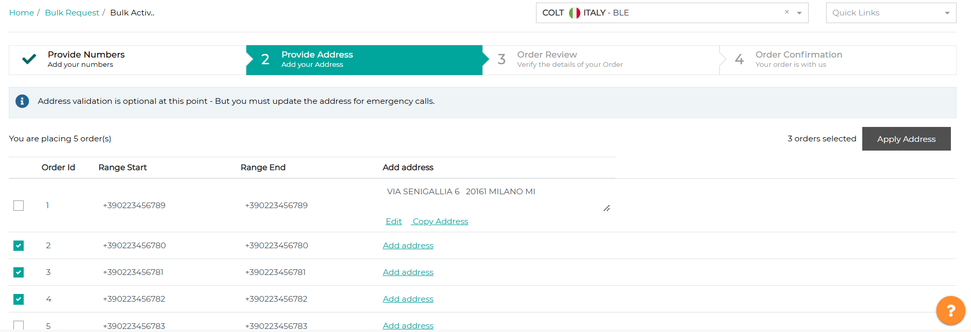

## Poland: Free number search, Number reservation, Number activation

Today when you search for free numbers in Poland the block sizes are: 1, 10 and 100.

As per the Polish rules in the numbering plan a block size of 100 only will be supported for free number search, reservation & activation:

