Colt Wholesale SIP (Number Hosting) 8th March 2025 Release Notes

Introduction
This document describes the Colt Wholesale SIP (Number Hosting) 8th March 2025 release.
The release will focus on
- Address Management & Directory Service in Portugal
- NOD and B2B API improvements
- New REST APIs on APIGEE
These changes might imply development at your end, so please read this document carefully.
The changes in this release require your support during our test period. The Customer UAT is planned from 17th Feb 2025 to 28th Feb 2025. Please get in touch with NumberHostingUATSupportTeam@COLT.NET if you would like to participate in the UAT.

Document change control
Version | Change description
V1 | 8th March 2025 Release note
V2 | Updates made on 5th Feb to these release notes with more details of the following:  - New ‘room’ field for PT, length is updated from 10 to 15 in section Address Management & Directory Services in Portugal  - 3 new changes (Sr no. 8-10) added in the Numbers on Demand (NOD) and B2B API improvements section  - Updated OAS specifications in sections New Wholesale SIP, Address Management, VAT Validation and Billing REST APIs and Appendix B: API specifications
V3 | Updates made on 21st Feb to these release notes with more details of the following:  - 2 new changes (Sr no. 11-12) added in the Numbers on Demand (NOD) and B2B API improvements section  - Added NOD screenshots in ‘Appendix C: Numbers on Demand UI changes’

Address Management & Directory Services in Portugal
To ensure regulatory compliance in Portugal, important changes relating to address management and validation will be implemented as follows:
- 2 new optional fields will be introduced (). Fields which are changing are marked as ‘New’ in the table below.
- Some validation of existing fields will be updated. Fields which are changing are marked ‘Update’ in the table below.
All changes are applicable in Portugal during number Activation, new Port-In, Address Update and address validation (validGeographicAddress REST API and validateAddress REST API) operations.
The fields are described in the table below:
Element | Description | Change | Current Type | Current Length | Updated Type | Updated Length | Customer Action
Emergency/Installation Address
endCustomerName | Name of the end customer | No Change | M | L ≤ 120 | - | - | No Change
buildingName | Name of the Building. | Update | O | L ≤ 20 | O | L ≤ 30 | Length increase to 30.
floorSuite | Name of the floor if any. | Update | O | L ≤ 5 | O | L ≤ 11 | Length increase to 11.
premisesNumber | Building Number. | Update | O | L ≤ 10 | M | L ≤ 12 | Length increase to 12 and made Mandatory.
unit | unit (apartment, suite) | New | - | - | O | L ≤ 10 | New optional field
room | A "room" (CAtype 28) is the smallest identifiable subdivision of a structure. | New | - | - | O | L ≤ 15 | New optional field
streetName | Name of the Street. | No Change | M | L ≤ 70 | - | - | No Change
subLocality | Name of the locality/town, when it differs from the one mentioned in postal code | No Change | M | L ≤ 50 | - | - | No Change
cityTown | Postal designation, i.e. Name of the town corresponding to the Postal Code. | No Change | M | L ≤ 50 | - | - | No Change
postalZipCode | Postcode followed by Number of the Town.  E.g.: 2790-114 | No Change | M | L ≤ 8 | - | - | No Change
Directory Service Update Details (Optional)
usageType | How the phone number is used | No Change | O | L ≤ 18 | - | - | No Change
confidentialityFlag | Information can be public (not confidential); completely confidential (all data) or confidentiality applied only to the address. | No Change | M | L ≤ 21 | - | - | No Change
confidentialityOtherFlag | Confidentiality in other informative services – data in other informative services can be public (not confidential), completely confidential or just the address is confidential. | No Change | O | L ≤ 21 | - | - | No Change
confidentialityReverseSearch | Do or do not allow a reverse search on the customer’s record based on the phone number and/or address. I.e. if the search is done based on the phone number or address, the customer's data may or may not be confidential. | No Change | M | L ≤ 27 | - | - | No Change

Numbers on Demand (NOD) and B2B API improvements
Below are 7 improvements targeted for release on 8th March 2025. Updated XSDs and API OAS specifications can be found in the Appendix A: XSD and Appendix B: API specifications.
Please note: Screenshots showing the NOD portal changes will be shared 10 days before the release.
Sr no | Functionality | Interface | Improvement Description | Country Scope | Code Breaking change for customer (Yes/No)
1 | Reservation  Direct activation | NOD | Today the Local Area Code (LAC) dropdown in NOD shows all France LACs and LAC + extension.  Now NOD will display only the list of LACs + extension in the dropdown for both Geo and Location Independent numbers which are owned by a customer.  User will be able to select the relevant LAC ( e.g.1) or LAC+extension (e.g. 17036) from the dropdown.  Customers with hosted location independent numbers: the existing textbox for entering a separate LAC extension will no longer appear and all the applicable LAC & LAC + extensions will be listed in the "Your Local Area Code (LAC)" dropdown to give you a better search function. | FR | No
2 | Number search | NOD and B2B APIs | Introduction of new number status: ‘Back To Regulator’ for Italy to cover these scenarios:  - A Colt Range is returned to the Regulator  - A Colt Range is re-assigned to another OLO by the Regulator  ‘Back To Regulator’ status will be applied by the local country manager after the following statuses: Activated, PortOut and Quarantined  Once a range is in ‘Back To Regulator’ status the lifecycle of the Colt range is terminated (i.e. numbers cannot be re-activated as Colt numbers).  ’numberDetails’ will show the endCustomer status as Inactive.  Impacted NOD functionality and APIs:  NOD: My Telephone Number page  SOAP/HTTPs: numberEnquiry  REST: GET/numberCollection  REST APIGEE: GET/number | IT | No  (Optional change)
3 | Number search | NOD and B2B APIs | Introduction of new number status ‘PortIn Deactivation In Progress’ and ‘PortIn Reactivation In Progress’  When a port-in deactivation and port-in reactivation request is raised, the number status for the requested range will be intermittently updated as ‘PortIn Deactivation In Progress’ and ‘PortIn Reactivation In Progress’ respectively.  When the port-in deactivation/reactivation request is completed, the number status is updated as BAU to Port-in quarantine / returned (as per the current country rules) and Port-In Activated respectively.  Impacted NOD functionality and APIs:  NOD: My Telephone Number page  SOAP/HTTPs: numberEnquiry  REST: GET/numberCollection  REST APIGEE: GET/number | All | No (Optional change)
4 | Block duplicate requests | NOD and B2B APIs | If the user raises a duplicate port-in deactivation/reactivation request, NOD & B2B APIs will block/fail these requests.  Post the generation of an orderID, port-in deactivation and port-in reactivation requests will fail with a business failure. | All | Yes  (for the duplicate orders)
5 | Change Porting Date  Modify PortIn requests | NOD and B2B APIs | If a user raises a duplicate port-in change porting date and port update (Action=’Modify Port’) request, NOD & B2B APIs will block/fail these requests.  An upfront error message will be thrown to block duplicate change porting date and modify port requests.  Impacted NOD functionality and APIs:  NOD: My order page  SOAP/HTTPs:  - updatePortIn  - transactionDataUpdate (Action=’Modify Port’)  REST:  - POST/numberCollectionPortOrderUpdate (Action=’Modify Port’)  APIGEE REST:  - POST/portUpdate/order (Action=’Modify Port’ and ‘Schedule porting’) | All | Yes (for the duplicate orders)
6 | Port-In, Change portin date and Modify port requests | B2B APIs | Today, whilst calculating the lead time for port-in, change portin date or modify port, the public holidays are not being considered and only the weekends are considered for the API.  This current behaviour will be modified and will be same as in NOD where both weekend and public holidays are considered while calculating the porting date lead time for all countries.  Impacted APIs:  SOAP/HTTPs:  - portIn,  - updatePortIn  - transactionDataUpdate (Action=’Modify Port’ and ‘Schedule porting’)  REST:  - POST/numberCollectionPortIn  - POST/numberCollectionPortOrderUpdate (Action=’Modify Port’ and ‘Schedule porting’)  APIGEE REST:  - POST/portIn/order  POST/portUpdate/order (Action=’Modify Port’ and ‘Schedule porting’) | All | Yes (if lead time is hardcoded)
7 | Order details | NOD and B2B APIs | Parent orderID will be visible as a new field in the order details for cancel and change port date requests.  Impacted NOD functionality and APIs:  NOD: Order Details page  SOAP/HTTPs: getTransactionDetails  REST: GET/order{orderID}  REST APIGEE: GET/order{orderID} | All | No (optional change)
8 | Activation  Address Update  PortIn  Address validation APIs | NOD and B2B APIs | Current behavior: , below characters are not supported for endCustomerName field and address fields for GB  ! Exclamation mark  ? Question Mark  / Forward slash  \ backwards slash  “ “ quotation marks  $ Dollar sign  £ Pound sign  * Asterisk  ( ) open or close brackets  + plus sign  > or < greater than or less than  ‘ Apostrophe  & ampersand should only be allowed in a Customer Name field & NOT in any other address field  New behavior: Now only below characters will not be supported for GB  ? Question Mark  \ backwards slash  $ Dollar sign  £ Pound sign  * Asterisk  + plus sign  > or < greater than or less than | GB | No
9 | Activation  Address Update  PortIn  Directory service updates  Address validation APIs | NOD and B2B APIs | Update of building name field length  Current length: 40  New length: 50 | IE | No
10 | Activation  Address Update  PortIn  Directory service updates  Address validation APIs | NOD and B2B APIs | Removal of current pattern restriction of building/house/premises number field pattern for All countries except BE, NL, DK, DE and Zone B countries.  Current allowed pattern: [0-9]+[ ]?[A-Za-z]*([\- /][0-9]+[A-Za-z]*)*"/  New behavior: User can enter any value in this field for the mentioned countries. | GB, ES, SE, PT, CH, AT, IT, IE, FR | No (optional change if the pattern is hardcoded- restriction can be removed)
11 | Activation  Address Update  PortIn  Directory service updates | NOD and B2B APIs | ‘Business Suffix/ businessSuffix’ field for Directory Service Update node  Current behavior: businessSuffix is required if customerType is Residential or Mixed.  New behavior: businessSuffix is now an optional field irrespective of customerType passed in the request. | AT | No (change is required if DS feature is opted)
12 | Port_In  Number report | NOD and B2B APIs | Port In:  You can now attach your RIO code file with your port-in request in .csv format  - NOD: ‘supplementary form’  - APIs: ‘anySupplementaryDocument’  Number Report:  France RIO code can now be downloaded using the number report functionality available on NOD  For more information see appendix C | FR | No

New Wholesale SIP, Address Management, VAT Validation and Billing REST APIs
As communicated in the Jan 2025 release notes, we plan to launch our new REST APIs on our APIGEE platform in January 2025 along with our API developer portal. In the March 2025 release, we plan to release our next set of APIs – address management, VAT validation and Billing APIs.
We will enable the industry standard authentication and authorisation mechanisms:-
- An Authentication API will be available. OAuth 2.0 access token with client_credential grant type used to authenticate API calls by a registered app. The access token has a limited validity period and the expiry time is returned in the response.
Release 1 - Jan 2025
Authorization API
Method: POST
oauth/token
API to generate access token to authorize REST API calls
Please refer to the OAS specification for details.

- JWT authentication: at the time of App registration you will find 3 options: URI, JWKS or certificate. Select any one option and then choose API bundles.

Below is the list of Wholesale SIP (Number Hosting) APIs in our January 2025 release:
Release 1 - Jan 2025
Number management
Method: POST |  | Method: GET
reservation/order  Reserve a number/range | updateCustomer/order  - Add or update end customer details/address & directory services details | freeNumberCount  Get free number count available for the requested numberPrefix
activation/order  Activate a number/range | bulkOrder  Activation, address update and PortIn | Order/{orderId}  Get orderDetails for the requested orderID
return/order  Cancel reservation or Deactivate activated/port-in activated number/range | reactivation/order  Reactivate quarantined or port-in quarantined number/range | freeNumber  Get free number search using prefix (All) and CLI (for FR only)
portIn/order  portIn a number/ranges to Colt | lockFreeNumbers  Lock free numbers using numberPrefix for 10 mins and receive lockID to perform reservation/activation | number  - Number search with status, CLI, orderID or cust reference.
portUpdate/order  - modify/ send notes/ schedule port(NL)/ cancel/ change the date of existing portIn order, Accept/reject a port out request | freeNumberBackfill/order  - Request for free numbers for required numberPrefix | order  Get list of orders
checkPortability  - Check if a number/range can be ported-In or not  - Internal Colt validations only | cancelFreeNumberBackfill/order  Cancel free number backfill order | CLIOrderHistory  Get the order history of the number or range
Please refer to the OAS specification for details.

Below is the list of Address Management, Billing and VAT Validation APIs in our March 2025 release:
Release 2 - March 2025
Address Management
Method: POST | Method: GET
validateAddress  API to validate the address (all 20 countries) | LACByLocation  - API to fetch valid LAC- Local area code  (all 20 countries) | Address/{addressId}  API to fetch address based on AddressId (not applicable for NL)
Please refer to the OAS specification for details.
VAT Validation API (ES and PT)
Method: POST
check-vat-number
API to validate the company registration number (VAT, CIF.NIF)
(ES and PT only)
Please refer to the OAS specification for details.
Billing (CDR APIs)
Method: POST | Method: GET
generateConsolidatedUnratedCallDetailRecord  API to request consolidated unrated CDRs | unratedCallDetailRecord  API to download unrated CDRs | ratedCallDetailRecord  API to download rated CDRs
 | consolidatedUnratedCallDetailRecord  API to download consolidated unrated CDRs | nonUsageReport  API to download non usage report
Please refer to the OAS specification for details.

How to get sandbox support
Support for sandbox testing will be provided by the API Support team and is a chargeable service. Please contact your account manager for further information.

Appendix A: XSD
Please click link 1 and link 2 for updated XSDs

Appendix B: API specifications

OAS Specification for number management APIs

Please click here for the OAS Specification for Number Management APIs.

OAS Specification for address management APIs

Please click here for the OAS Specification for Number Management APIs.

Appendix C: Numbers on Demand UI changes

Portugal address section- Introduction of new fields- room and unit
Applicable for activation, address update and port-in (including bulk)
Current behaviour | New behaviour
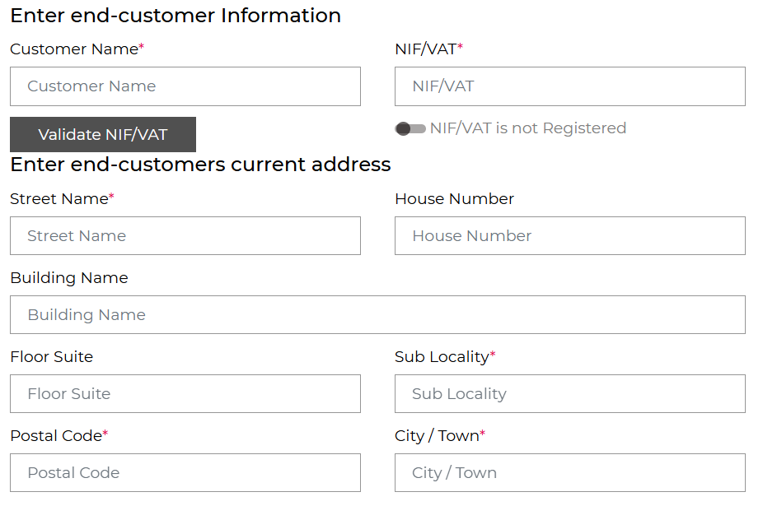 | 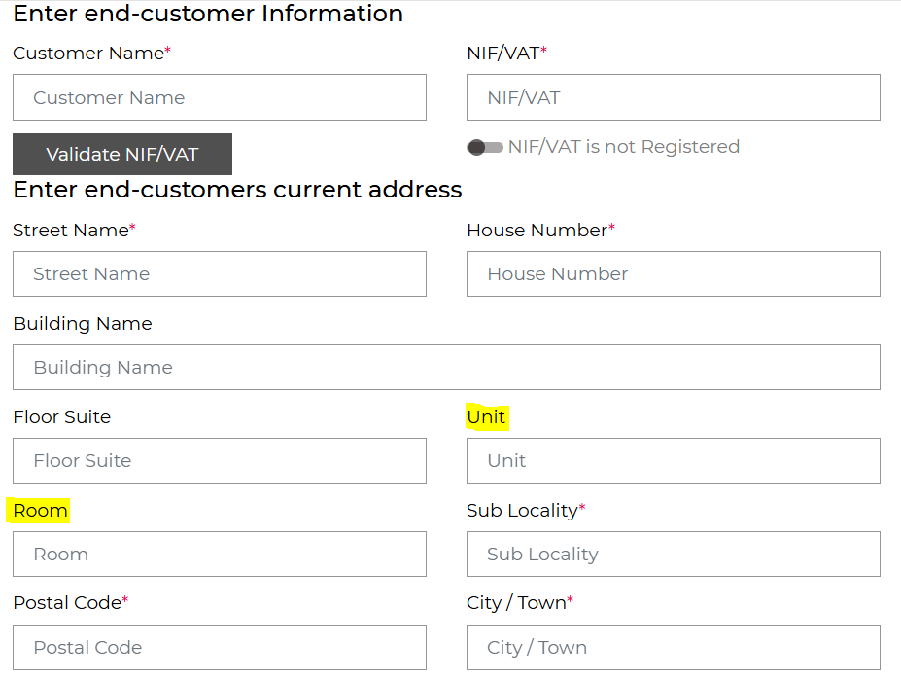

FR (Hosted customers only): display of applicable LACs in the dropdown
Applicable for number reservation and direct activation screens.
We’ll no longer display all French Local Area Codes in the dropdown. Only the LACs where you’ve free numbers available will be displayed in the dropdown.
Current behaviour | New behaviour
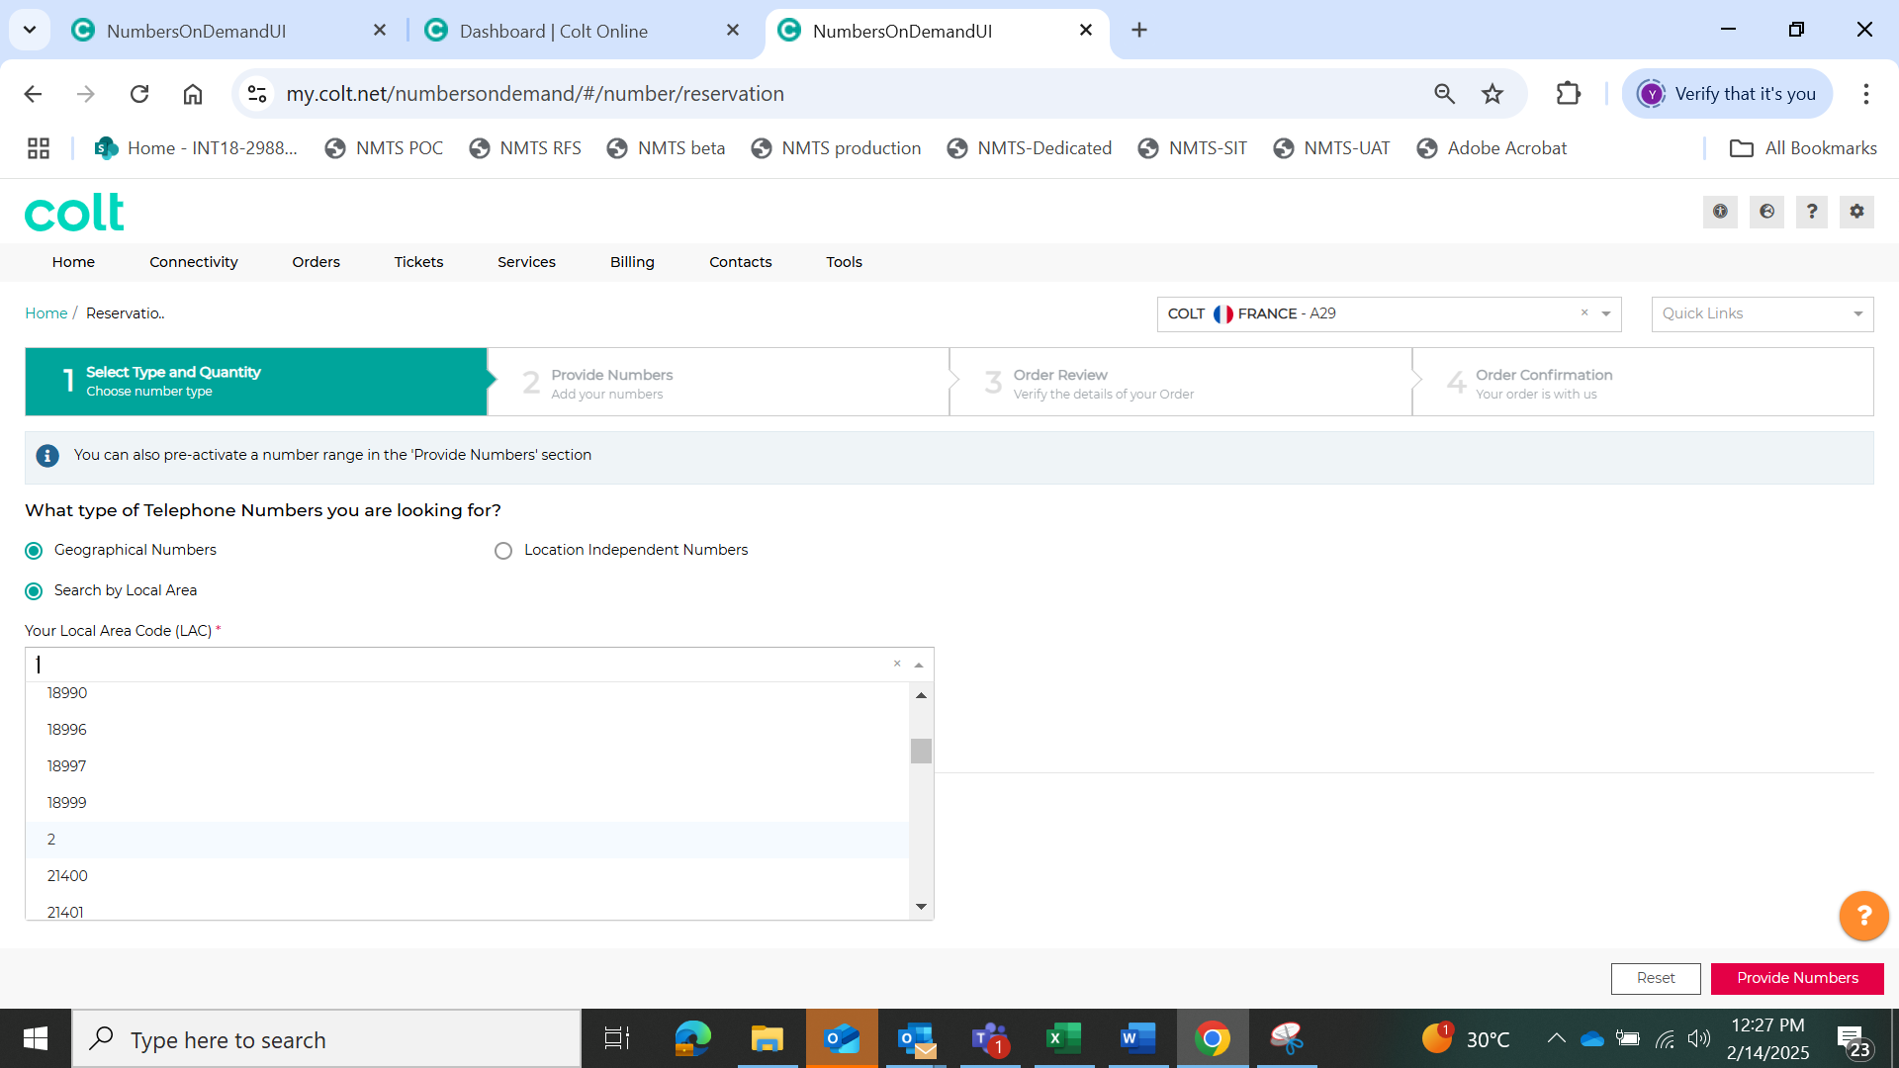 | 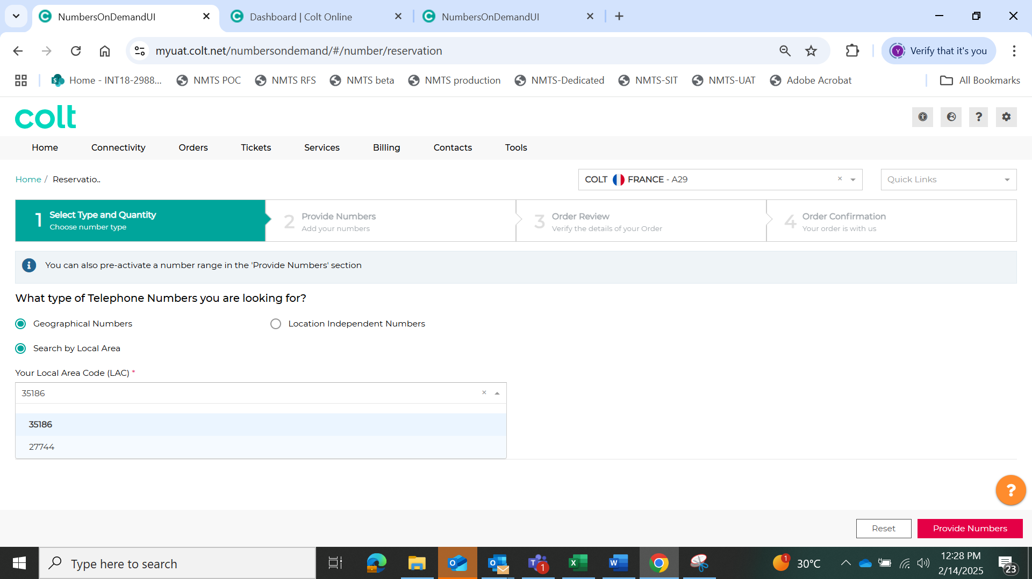

New Number status added in ‘My Telephone Number’ page
Number status filter and status place cards can be used to view the new status
- Italy: Back to the regulator
- All countries: PortIn Deactivation In Progress, PortIn Reactivation In Progress

Current behaviour | New behaviour
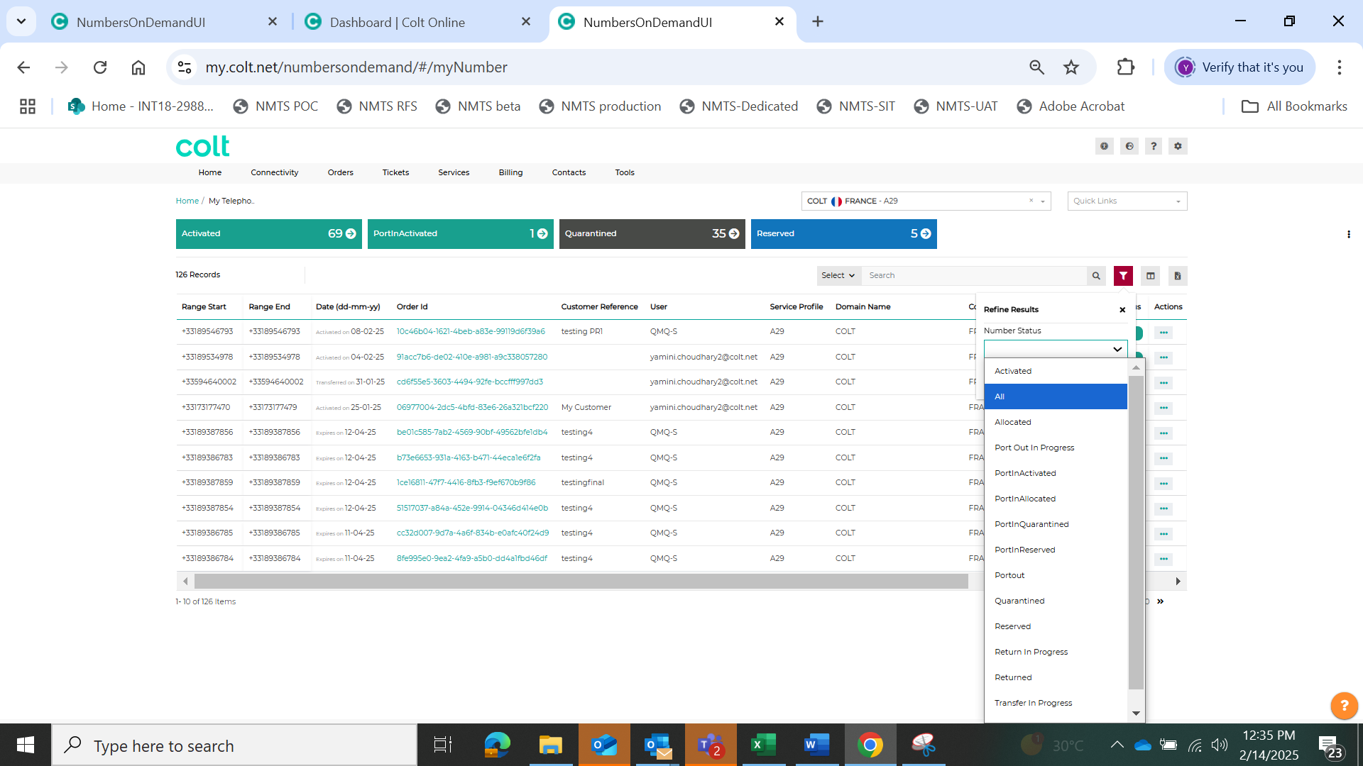 | 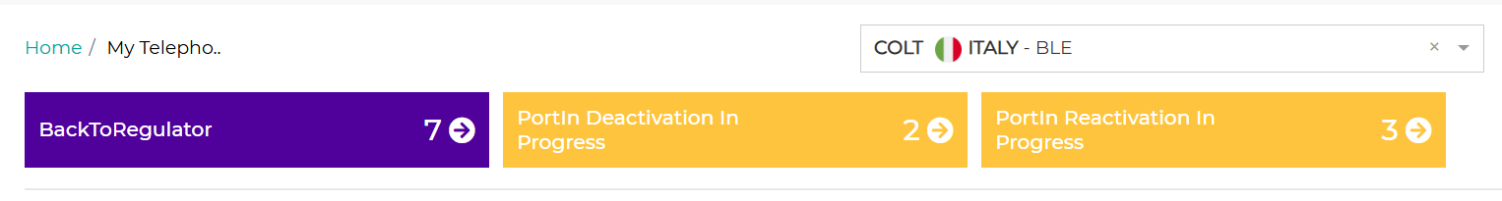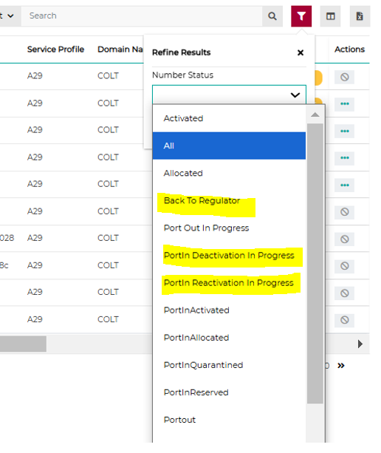

Order details screen: Display of parent order ID against the cancel port-in, date change or any child order updates.

Current behaviour | New behaviour
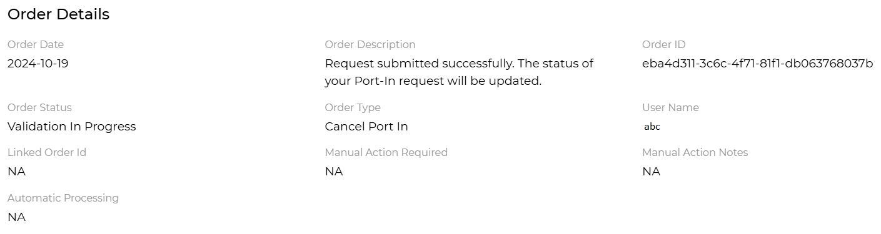  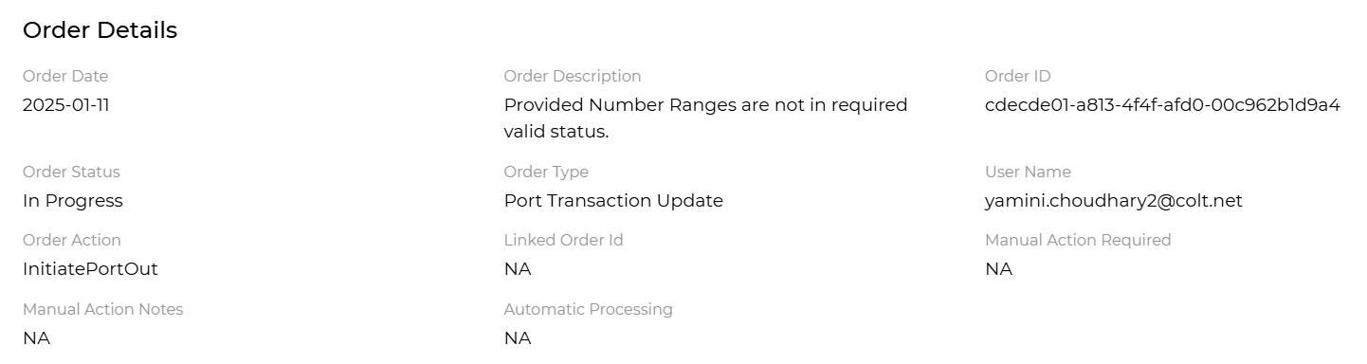 | 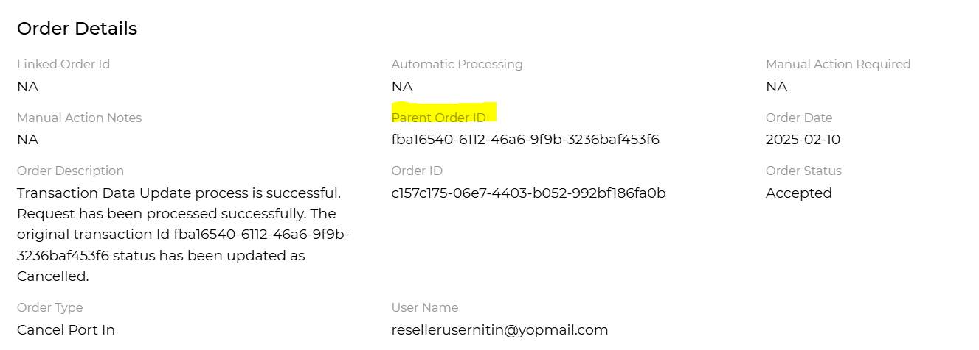  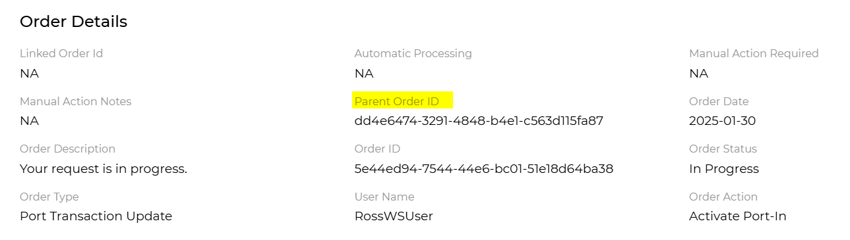

France- upload RIO code file and download Number report with RIO code

There are some changes to the use of RIO codes in France, which come into effect from 1st July 2025, pursuant to Arcep’s decision no 2022-2148.
A RIO code is a unique identifier associated to a telephone number created when an end user requests a new telephone number in France.
RIO codes must be made available to the entire business market today for information purposes.
RIO codes are gradually becoming mandatory for porting requests:-
- Today RIO codes are required for porting requests related to the consumer and small business ports as well as for cross-border requests. ( NB: Cross border requests are where a geographic number is ported in from/to a consumer from/to a business service.) The purpose of a RIO code is to facilitate and secure the portability process. If a consumer or small business wish to move / port numbers to a new operator, then the new operator will request the RIO code provided by the current operator for each single telephone number, in order to validate that the port order is legitimate and to implement the porting order
- From 1st July 2025 RIO codes will also be required for single number portability requests (i.e. IN non-geographic numbers such as Freephone, Shared Cost & Premium Rate numbers only) and included in an optional supplementary attachment to a port order (see file format below)

What does this mean for Wholesale SIP customers?
How to find a RIO code
You can find the RIO code for each geographic & location independent number assigned to your end-customer by:-
- Viewing the ‘Number Details’ in the Numbers on Demand portal for a given number, or
- The RIO code will be returned in the B2B API response (SOAP/HTTPs: getNumberDetails ; REST API: GET/CLIDetails and new REST API: GET/numbers), or
- Following our Mar25 release, requesting and downloading a Number Report of all of your activated numbers with their associated RIO codes at CLI level from the Numbers on Demand portal – see snapshot:-
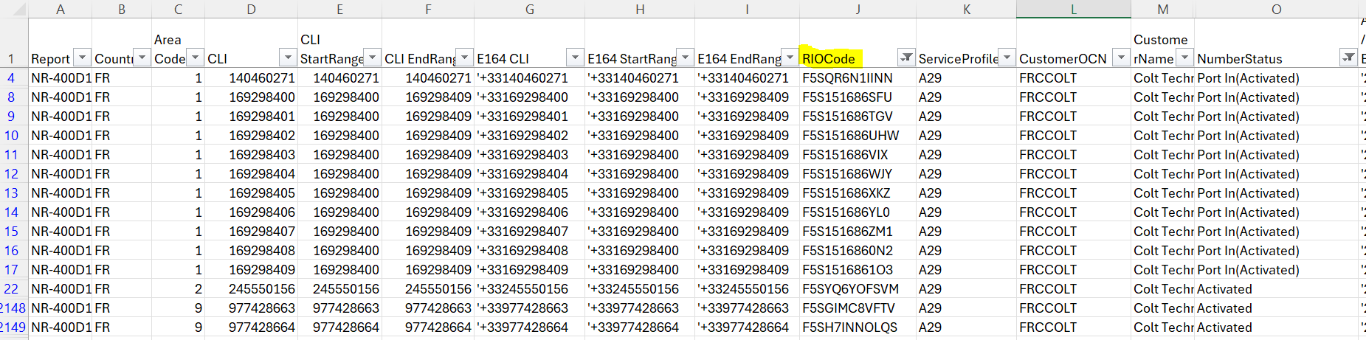
Impacts to port-in orders
- No impact - from 1st July 2025 RIO codes will remain non-mandatory for a port-in order of a geographic or location independent number when assigned to a business. These numbers are not classed as single numbers, they are classed as group numbers
- Optional impact – Following the Mar25 release you will have an option to upload a csv file containing the information in the table below to your port-in order – see snapshot. This information will then be checked with the losing/donor operator and improve the accuracy of the port.
Current behaviour | New behaviour
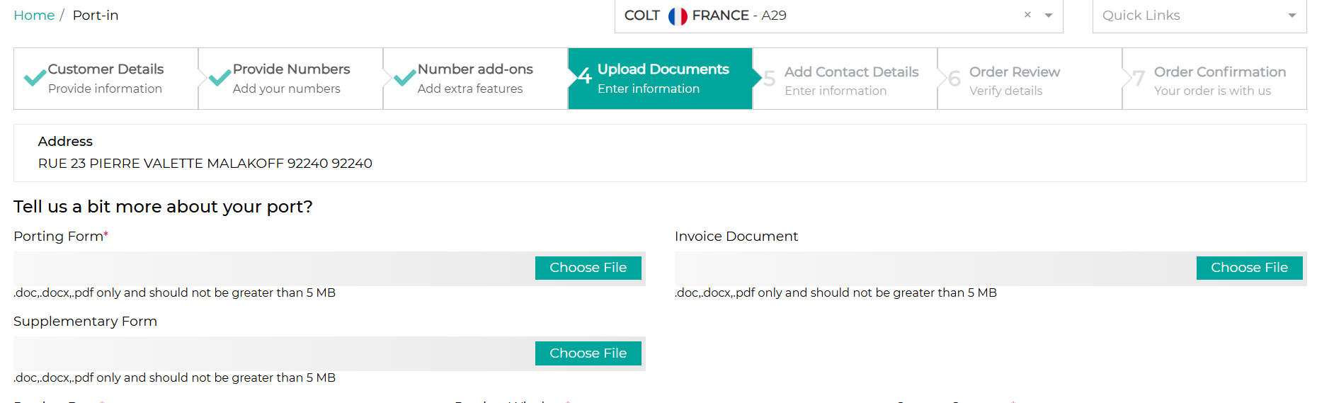 | 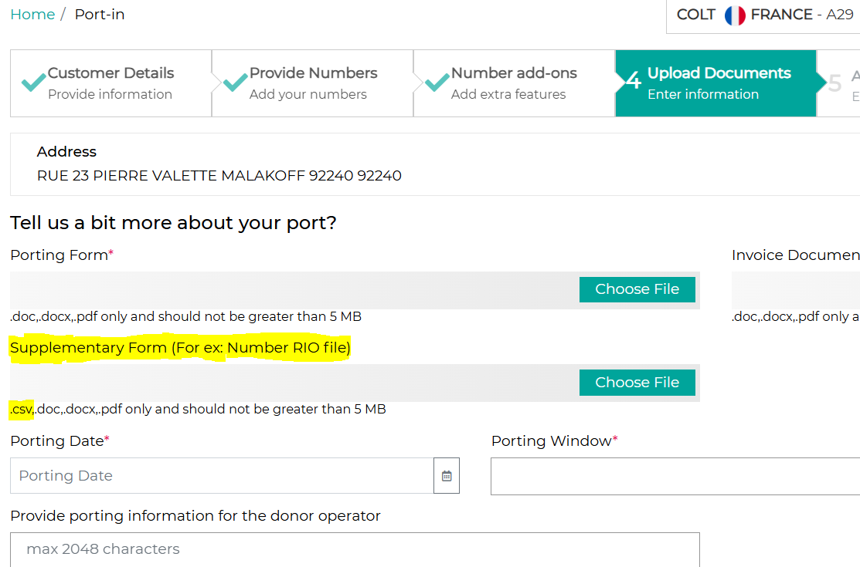

- If your end-customer asks for their details for a port-out request, you can find the details required for the csv file by downloading both the Number Report and the Order Report from the Numbers on Demand portal or by retrieving the number & order details over API.

RIO code file format as defined by APNF:-
Name | Description | Format | Mandatory / Optional /Conditional | Example
Numéro | Number | Numeric (10) with leading ‘0’. | M | 0123456789
RIO | RIO | Alphanumeric (12) | C
 |  | OO Q RRRRR CCC
NDI | Group Main Number | Numeric (10) with leading ‘0’ | M | 0123456789
RS | Customer Name | Alphanumeric (64) | C | XYZ bank
SIRET | Customer Site registration number | Numeric (14) | C | 98765432101234
NUMERO DE LA VOIE | Address: Street Nb | Alphanumeric (10) | C | 2
LIBELLE DE LA VOIE | Address: Street Name | Alphanumeric (124) | C | Rue de Charonne
CODE POSTAL | Address: Postal Code | Numeric (5) | C | 75011
COMMUNE | Address: City Name | Alphanumeric (64) | C | PARIS
DATE QUARANTAINE | Date of quarantine | YYYYMMDD | O | 20241128

Rules
- RIO code is mandatory if the Number is a non-geo IN number, else it should be empty
- RS, SIRET and the Address fields are optional if the Number is a non-geo IN number, and mandatory for all geographic / location independent numbers
- DATE QUARANTAINE : empty if the Number is activated, optional if the Number is in quarantine status.

